**Module 7: Assignment 3: UI Rendering Integrate Sign-up and Log-In**

Nikita Goel

Arizona State University

IFT 598: Middleware Programming & Database Security

Professor. Dinesh Sthapit

November 26, 2022

Replicated the module 7 assignment 2 code for this assignment and downloaded the dependencies (Figure 1)

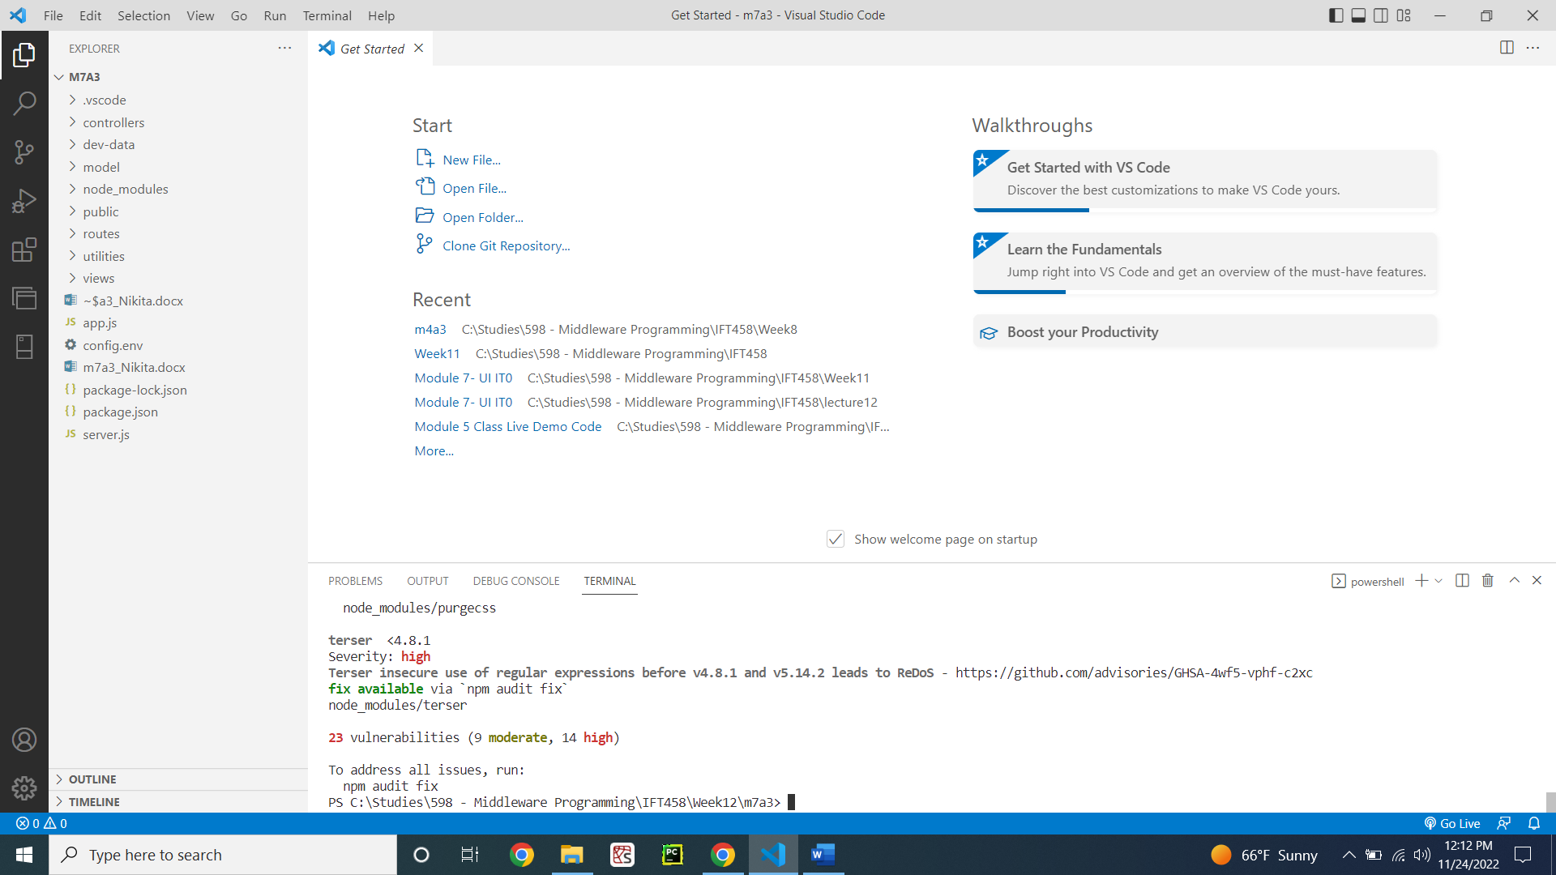

Figure 1: m7a2 code with dependencies

**Step 1: Sign In a new user**

Already created getSignInForm function in the viewController.js (Figure 2)

**Code:**

const axios = require('axios');

const User = require('./../model/userModel');

// exports.getLandingPAge = async (req, res) => {

//   res.status(200).render('overview', {

//     title: `Over View`

//   });

// };

exports.getLoginForm = (req, res) => {

  res.status(200).render('login', {

    title: 'Log into your account'

  });

};

exports.getSignInForm = (req, res) => {

  res.status(200).render('newUser', {

    title: 'Sign in New User'

  });

};

exports.getCourse = async (req, res) => {

  res.status(200).render('courses', {

    title: `Get Course`

  });

};

exports.createNewCourse = async (req, res) => {

  res.status(200).render('newCourse', {

    title: `Create New Course`

  });

};

// adding the loan list for the views

exports.getLoan = async (req, res) => {

  const query = await axios.get('http://localhost:3000/api/v1/loans')

  console.log(query.data.loans)

  res.status(200).render('loanlist', {

    title: `Get loanlists`,

    "loans": query.data.loans

  });

};

exports.getCoursesJSON = async (req, res) => {

  res.status(200).render('allCourses', {

    title: `Get courses from JSON`,

    "courses": courses

  });

};

// exports.getLoginUser = (req, res) => {

//   const {email, password} = req.body;

//   res.status(200).render('login', {

//     title: 'Log into your account'

//   });

// };

exports.home = async (req, res) => {

  if (req.session.userId){

    User.findById(req.session.userId)

    .exec(function (error, user) {

      console.log(user)

      if (error) {

        res.status(200).render('overview', {

          title: `Over View`

        });

      } else {

        return res.render('overview', { title: 'Over View', name: user.name});

      }

      req.session.name = user.name

    });

  }

  else {

    res.status(200).render('overview', {

    title: `Over View`

  });

  }

};

exports.getAllUser = async (req, res) => {

  // console.log(req.session)

  const query = await axios.get('http://localhost:3000/api/v1/users/')

  // console.log(query.data)

  res.status(200).render('alluserlists', {

    title: `Get userlists`,

    "users": query.data.users,

    name: req.session.name

  });

};

exports.getMyLoan = async (req, res) => {

  // console.log(req.session)

  const query = await axios.get('http://localhost:3000/api/v1/loans/My',{params:{name:req.session.name}})

  // console.log(query.data.loans)

  res.status(200).render('myloanlists', {

    title: `Get loanlists`,

    "loans": query.data.loans,

    name: req.session.name

  });

};

exports.CreateNewLoan = (req, res) => {

  res.status(200).render('newLoan', {

    title: 'Create New Loan',

    name: req.session.name

  });

};

exports.logout = (req, res) => {

  if (req.session) {

    // delete session object

    req.session.destroy(function(err) {

      if(err) {

        return next(err);

      } else {

        return res.redirect('/');

      }

    });

  }

};

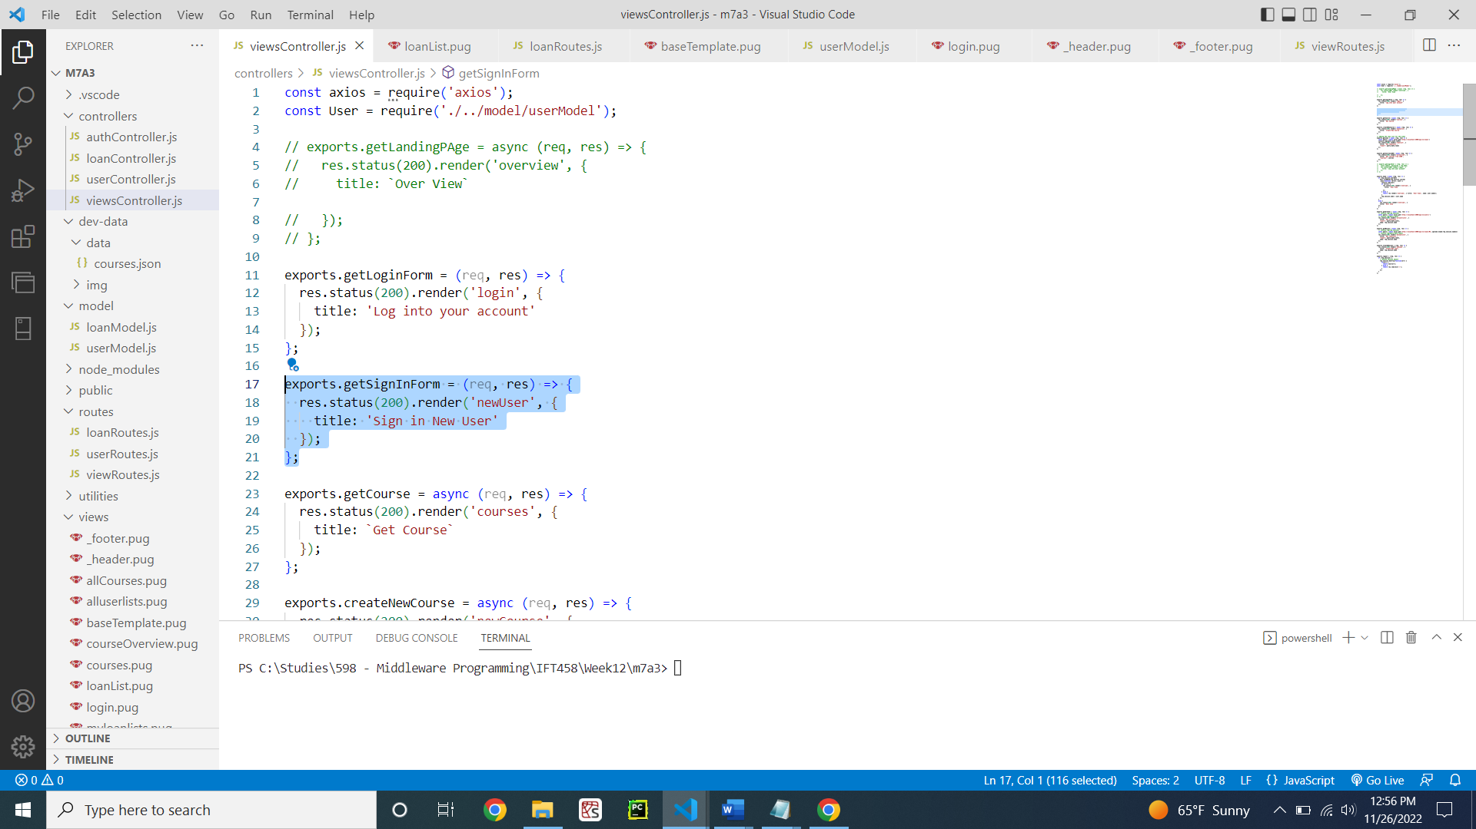

Figure 2: viewController.js containing the sign in option

Pug file for signing up the user (Figure 3)

**Code:**

extends baseTemplate

block content

  main.main

    .card-container

      .card

        .card__header

          h3.heading-tertirary

            span Sign In

        .card__details

          h4.card__sub-heading New Student

          p.card__text

            | Please enter the following Details

          .card__data

            svg.card__icon

              use(xlink:href='img/icons.svg#icon-map-pin')

            form(action='/api/v1/users/signup' method='post')

              label(for='name') Full name:

              input#name(type='text' name='name')

              br

              br

              label(for='email') Email:

              input#email(type='email' name='email')

              br

              br

              label(for='role') Role:

              input#role(type='text' name='role')

              br

              br

              label(for='password') Password:

              input#password(type='password' name='password')

              br

              br

              label(for='passwordConfirm') Confirm Password:

              input#passwordConfirm(type='password' name='passwordConfirm')

              br

              br

              input.card__sub-heading(type='submit' value='Submit')

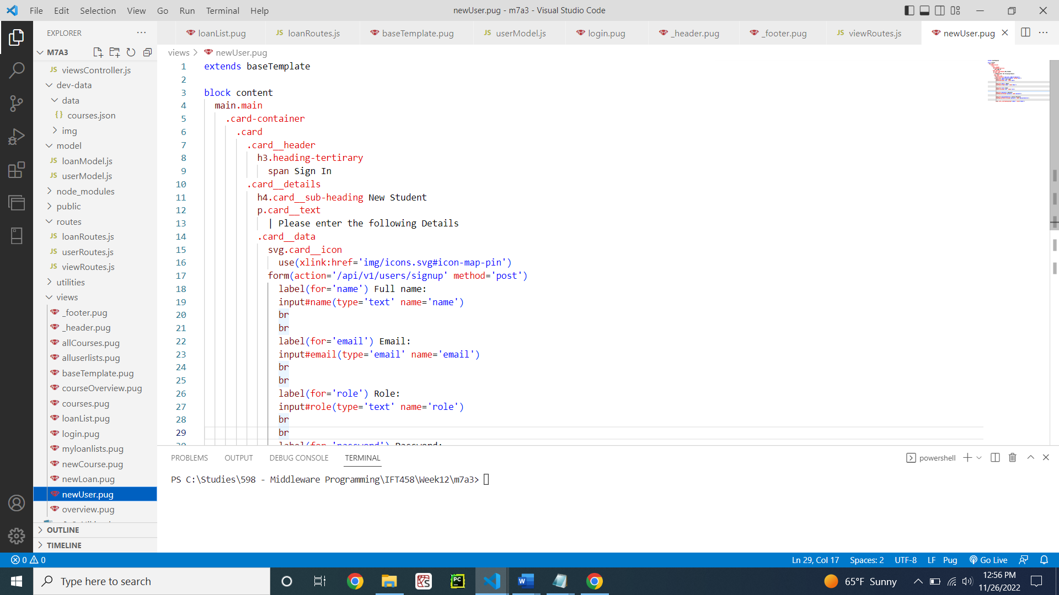

Figure 3: PUG file for signing up new user

viewRoutes.js calling the view controller (Figure 4)

**Code:**

const express = require('express');

const viewsController = require('../controllers/viewsController');

const router = express.Router();

router.get('/', viewsController.home);

// router.get('/courses', viewsController.getCourse);

router.get('/myloanlists', viewsController.getMyLoan);

router.get('/allloanlists', viewsController.getLoan);

router.get('/createNewLoan', viewsController.CreateNewLoan);

router.get('/alluserlists', viewsController.getAllUser);

router.get('/loanList', viewsController.getMyLoan);

router.get('/logout', viewsController.logout);

router.get('/login', viewsController.getLoginForm);

router.get('/signup', viewsController.getSignInForm);

// router.get('/newCourse', viewsController.createNewCourse);

// router.get('/courseList', viewsController.getCoursesJSON);

module.exports = router;

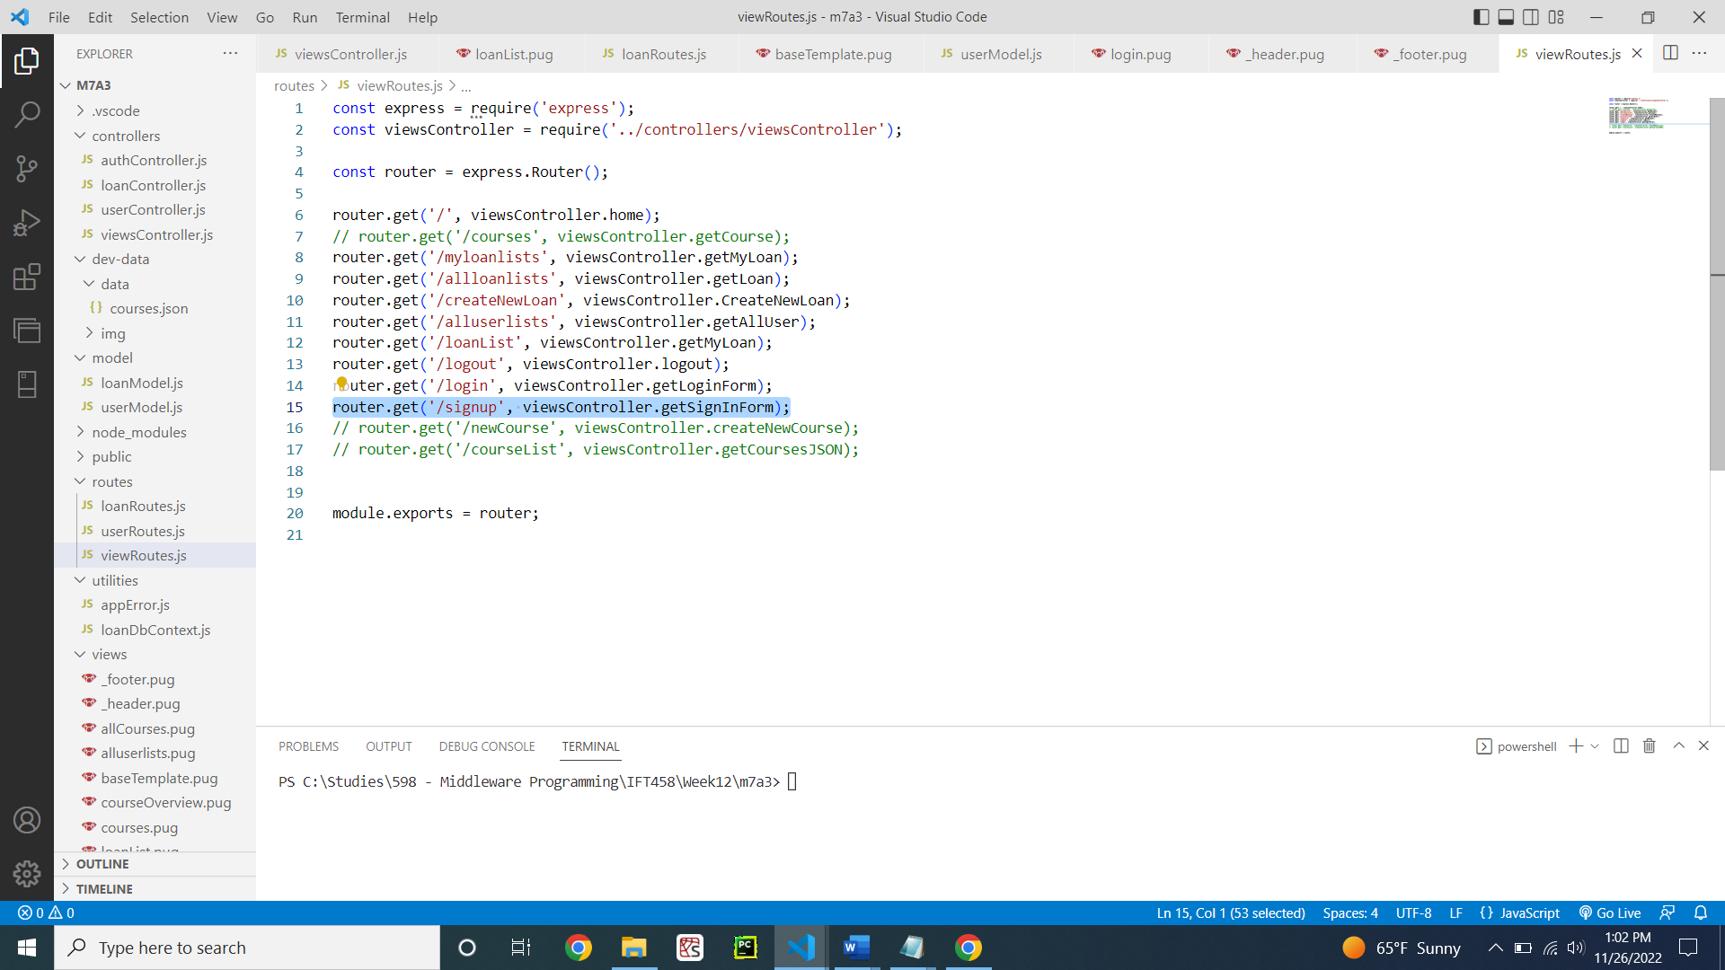

Figure 4: viewRoutes.js for signup

userRoutes.js calling the auth controller to sign up new user (Figure 5)

**Code:**

const express = require('express');

const userController = require('./../controllers/userController');

const authController = require('./../controllers/authController');

const router = express.Router();

router.post('/login', authController.login);

router.post('/signup', authController.signup);

router.get('/logout', authController.logout);

router

  .route('/')

  .get(userController.getAllUsers)

  .post(userController.createUser);

router

  .route('/:id')

  .get(userController.getUser)

  .patch(userController.updateUser);

module.exports = router;

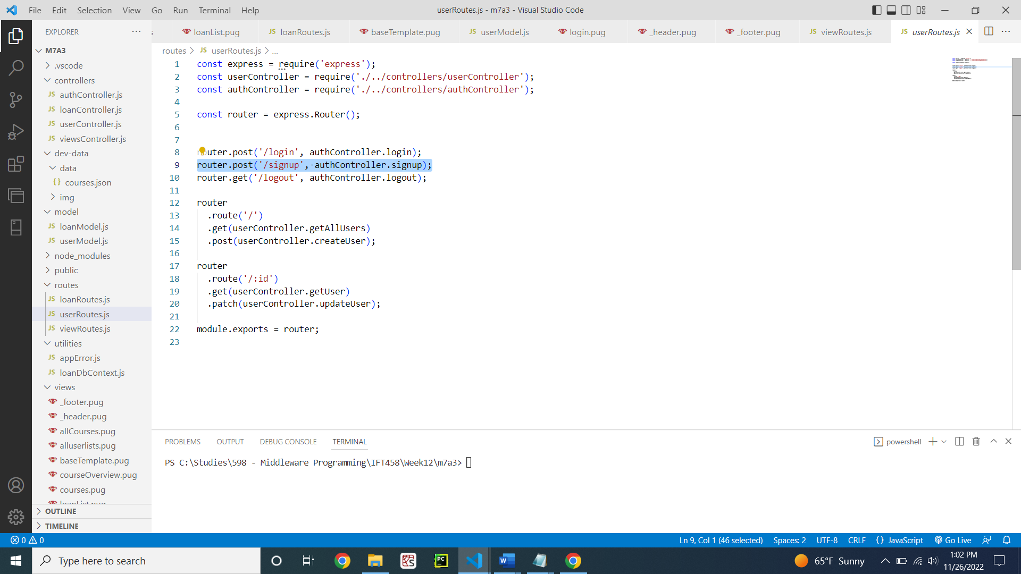

Figure 5: userRoutes.js for new user signup

Authcontroller.js creating a new user (Figure 6)

**Code:**

const crypto = require('crypto');

const jwt = require('jsonwebtoken');

const User = require('./../model/userModel');

const AppError = require('./../utilities/appError');

const util = require('util');

const express = require('express');

const alert =require('alert')

require('util.promisify').shim();

const signToken = id => {

  return jwt.sign({ id }, process.env.JWT_SECRET, {

    expiresIn: process.env.JWT_EXPIRES_IN

  });

};

const createSendToken = (user, statusCode, res) => {

  const token = signToken(user._id);

  const cookieOptions = {

    expires: new Date(

      Date.now() + process.env.JWT_COOKIE_EXPIRES_IN * 24 * 60 * 60 * 1000

    ),

    httpOnly: true

  };

  if (process.env.NODE_ENV === 'production') {

    cookieOptions.secure = true;

  }

  res.cookie('jwt', token, cookieOptions);

  // Remove password from output

  user.password = undefined;

};

exports.signup = async (req, res, next) => {

  console.log(req.body)

  const newUser = await User.create({

    name: req.body.name,

    email: req.body.email,

    password: req.body.password,

    passwordConfirm: req.body.passwordConfirm

  });

  createSendToken(newUser, 201, res);

  console.log('sign up successfully')

  req.session.email = newUser.email

  req.session.name = newUser.name

  req.session.userId = newUser._id;

  res.redirect('/')

};

exports.login = async (req, res, next) => {

  const { email, password } = req.body;

  // 1) Check if email and password exist

  if (!email || !password) {

    return next(new AppError('Please provide email and password!', 400));

  }

  //authentication

  // 2) Check if user exists && password is correct

  const user = await User.findOne({ email }).select('+password');

  if (!user || !(user.correctPassword(password, user.password))) {

    return next(new AppError('Incorrect email or password', 401));

  }

  //end of authentication

  // 3) If everything ok, send token to client

  createSendToken(user, 200, res);

  req.session.email = user.email

  req.session.name = user.name

  req.session.userId = user._id;

  alert("successfully!!!")

  res.redirect('/')

};

exports.logout = (req, res) => {

  res.cookie('jwt', 'loggedout', {

    expires: new Date(Date.now() + 10 * 1000),

    httpOnly: true

  });

  res.status(200).json({ status: 'success' });

};

exports.protect = async (req, res, next) => {

  // 1) Getting token and check of it's there

  let token;

  if (

    req.headers.authorization &&

    req.headers.authorization.startsWith('Bearer')

  ) {

    token = req.headers.authorization.split(' ')[1];

  } else if (req.cookies.jwt) {

    token = req.cookies.jwt;

  }

  if (!token) {

    return next(

      new AppError('You are not logged in! Please log in to get access.', 401)

    );

  }

  // 2) Verification token

  const decoded = await util.promisify(jwt.verify)(token, process.env.JWT_SECRET);

  // 3) Check if user still exists

  const currentUser = await User.findById(decoded.id);

  if (!currentUser) {

    return next(

      new AppError(

        'The user belonging to this token does no longer exist.',

        401

      )

    );

  }

  // 4) Check if user changed password after the token was issued

  if (currentUser.changedPasswordAfter(decoded.iat)) {

    return next(

      new AppError('User recently changed password! Please log in again.', 401)

    );

  }

  // GRANT ACCESS TO PROTECTED ROUTE

  req.user = currentUser;

  res.locals.user = currentUser;

  next();

  res.status(201).json({

    status: 'success',

    token,

    data: {

      currentUser

    }

  });

};

// Only for rendered pages, no errors!

exports.isLoggedIn = async (req, res, next) => {

  if (req.cookies.jwt) {

    try {

      // 1) verify token

      const decoded = await promisify(jwt.verify)(

        req.cookies.jwt,

        process.env.JWT_SECRET

      );

      // 2) Check if user still exists

      const currentUser = await User.findById(decoded.id);

      if (!currentUser) {

        return next();

      }

      // 3) Check if user changed password after the token was issued

      if (currentUser.changedPasswordAfter(decoded.iat)) {

        return next();

      }

      // THERE IS A LOGGED IN USER

      res.locals.user = currentUser;

      return next();

    } catch (err) {

      return next();

    }

  }

  next();

};

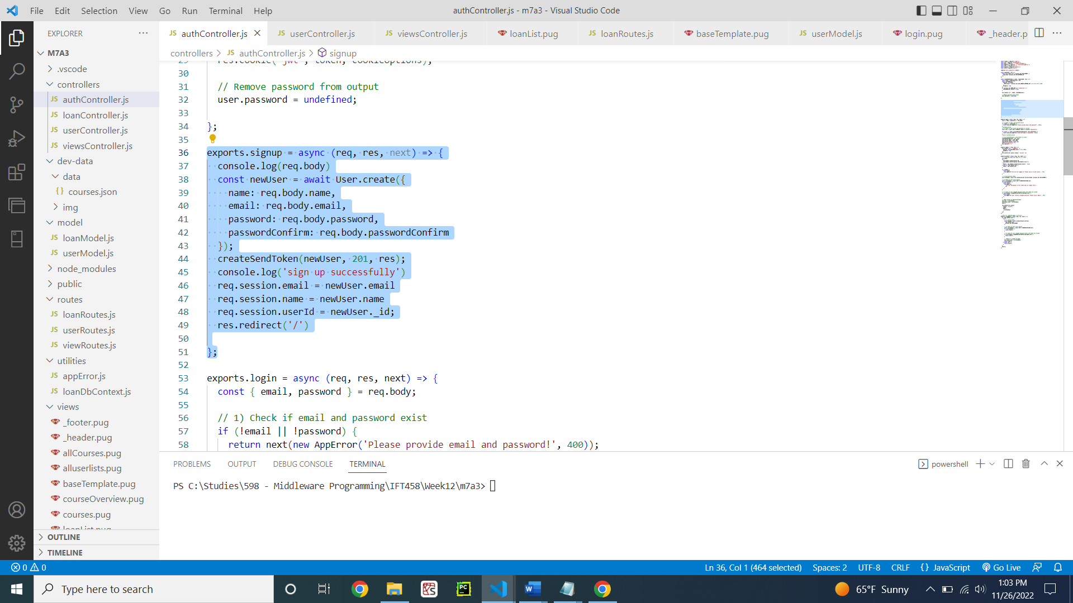

Figure 6: new user validation in authcontroller.js

Usercontroller.js creating a new user (Figure 7)

**Code:**

const User = require('./../model/userModel');

exports.getAllUsers = async (req, res, next) => {

  const users = await User.find();

  // SEND RESPONSE

  res.status(200).json({

    status: 'success',

    results: users.length,

    users

  });

};

exports.createUser = async (req, res) => {

  const newUser = await User.create({

    name: req.body.name,

    email: req.body.email,

    password: req.body.password,

    passwordConfirm: req.body.password // this needs to be changed

  });

  res.status(201).json({

    status: 'success',

    data: newUser

  });

};

exports.deleteMe = async (req, res) => {

  await User.findByIdAndUpdate(req.user.id, { active: false });

  res.status(204).json({

    status: 'success',

    data: null

  });

};

exports.getUser = (req, res) => {

  res.status(500).json({

    status: 'error',

    message: 'This route is not yet defined!'

  });

};

exports.updateUser = (req, res) => {

  res.status(500).json({

    status: 'error',

    message: 'This route is not yet defined!'

  });

};

exports.deleteUser = (req, res) => {

  res.status(500).json({

    status: 'error',

    message: 'This route is not yet defined!'

  });

};

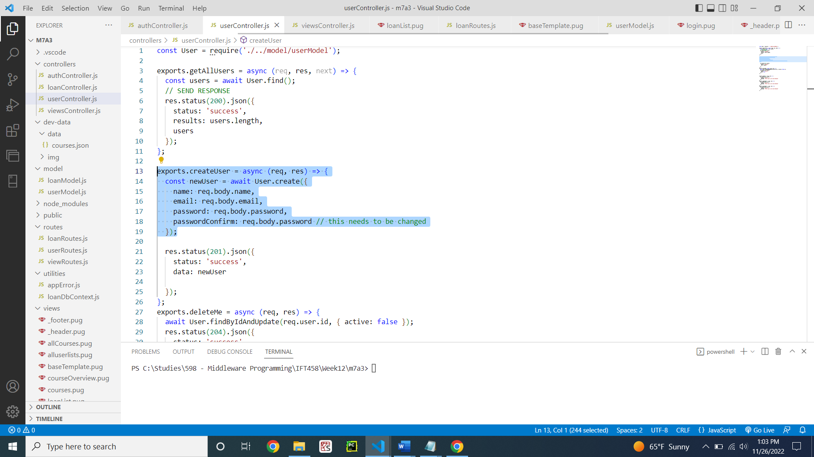

Figure 7: usercontroller.js file

Demonstration of code in UI (Figure 8 - 13)

Figure 8 shows the code executed successfully without any errors.

Figure 9 shows the MongoDB database created successfully.

Figure 10 shows the overview page obtained when I hit localhost:3000/

Figure 11 shows the sign up page for new user.

Figure 12 shows that after I submit the information in sign up page the new user gets logged in with their name on the top right side of the screen.

Figure 13 shows that the new user that I created got inserted in the MongoDB too.

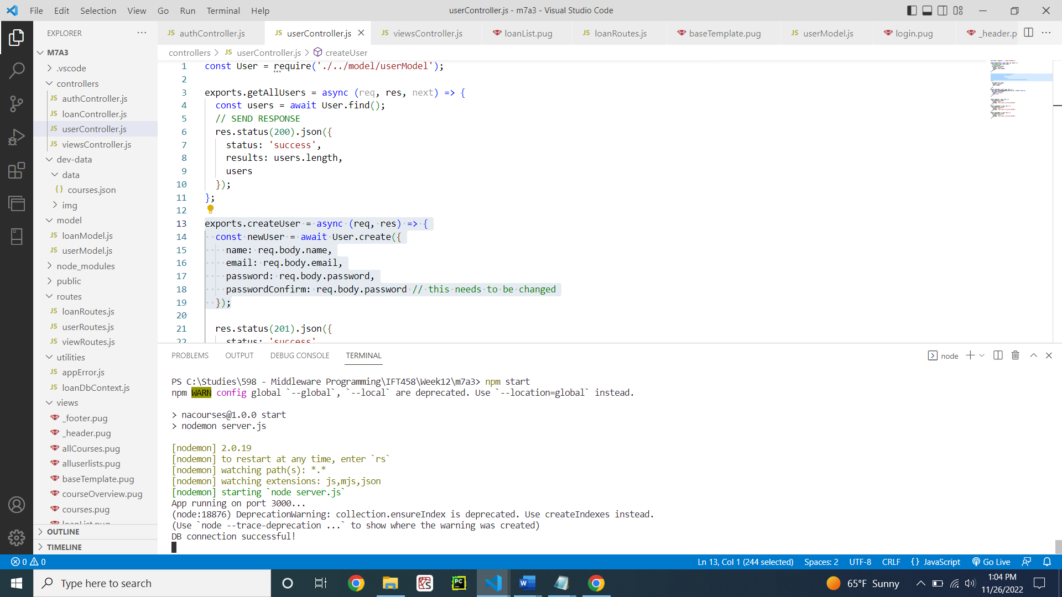

Figure 8: Code executing successfully

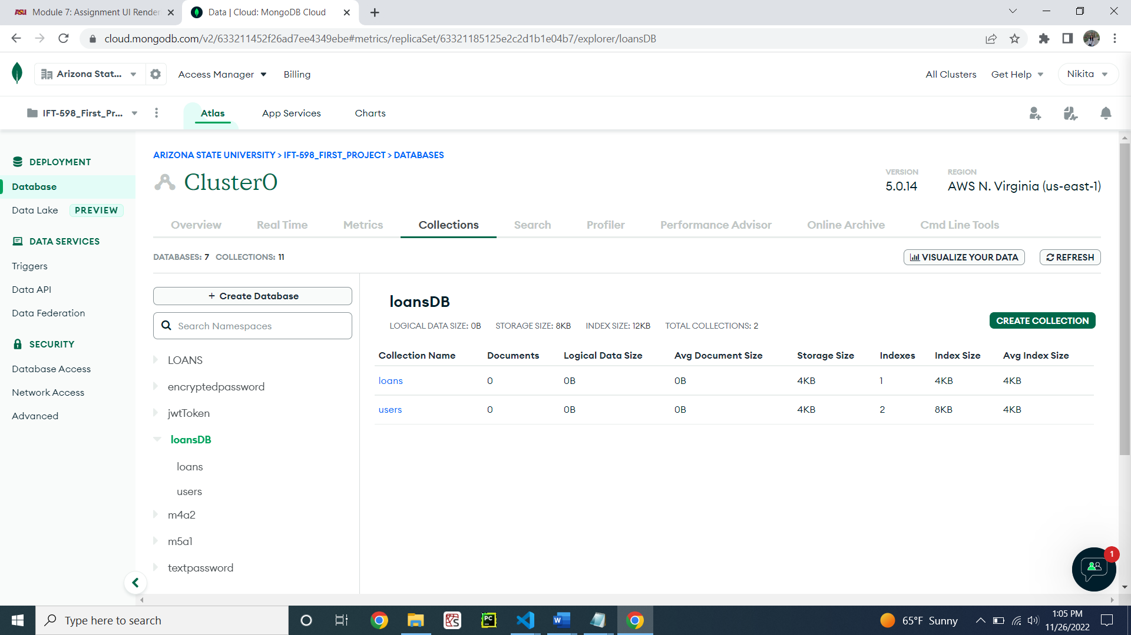

Figure 9: Database connected and created successfully

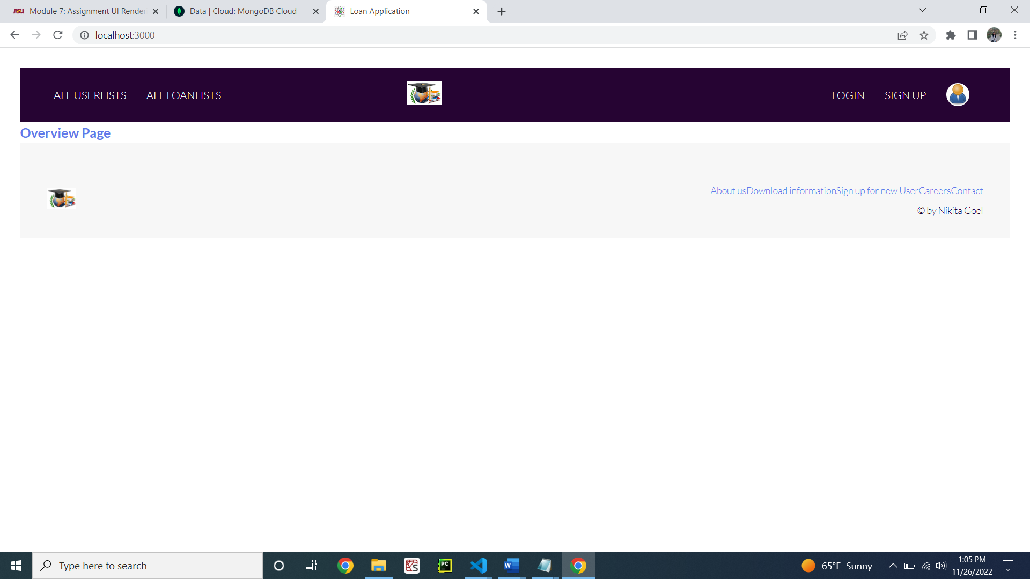

Figure 10: Overview page

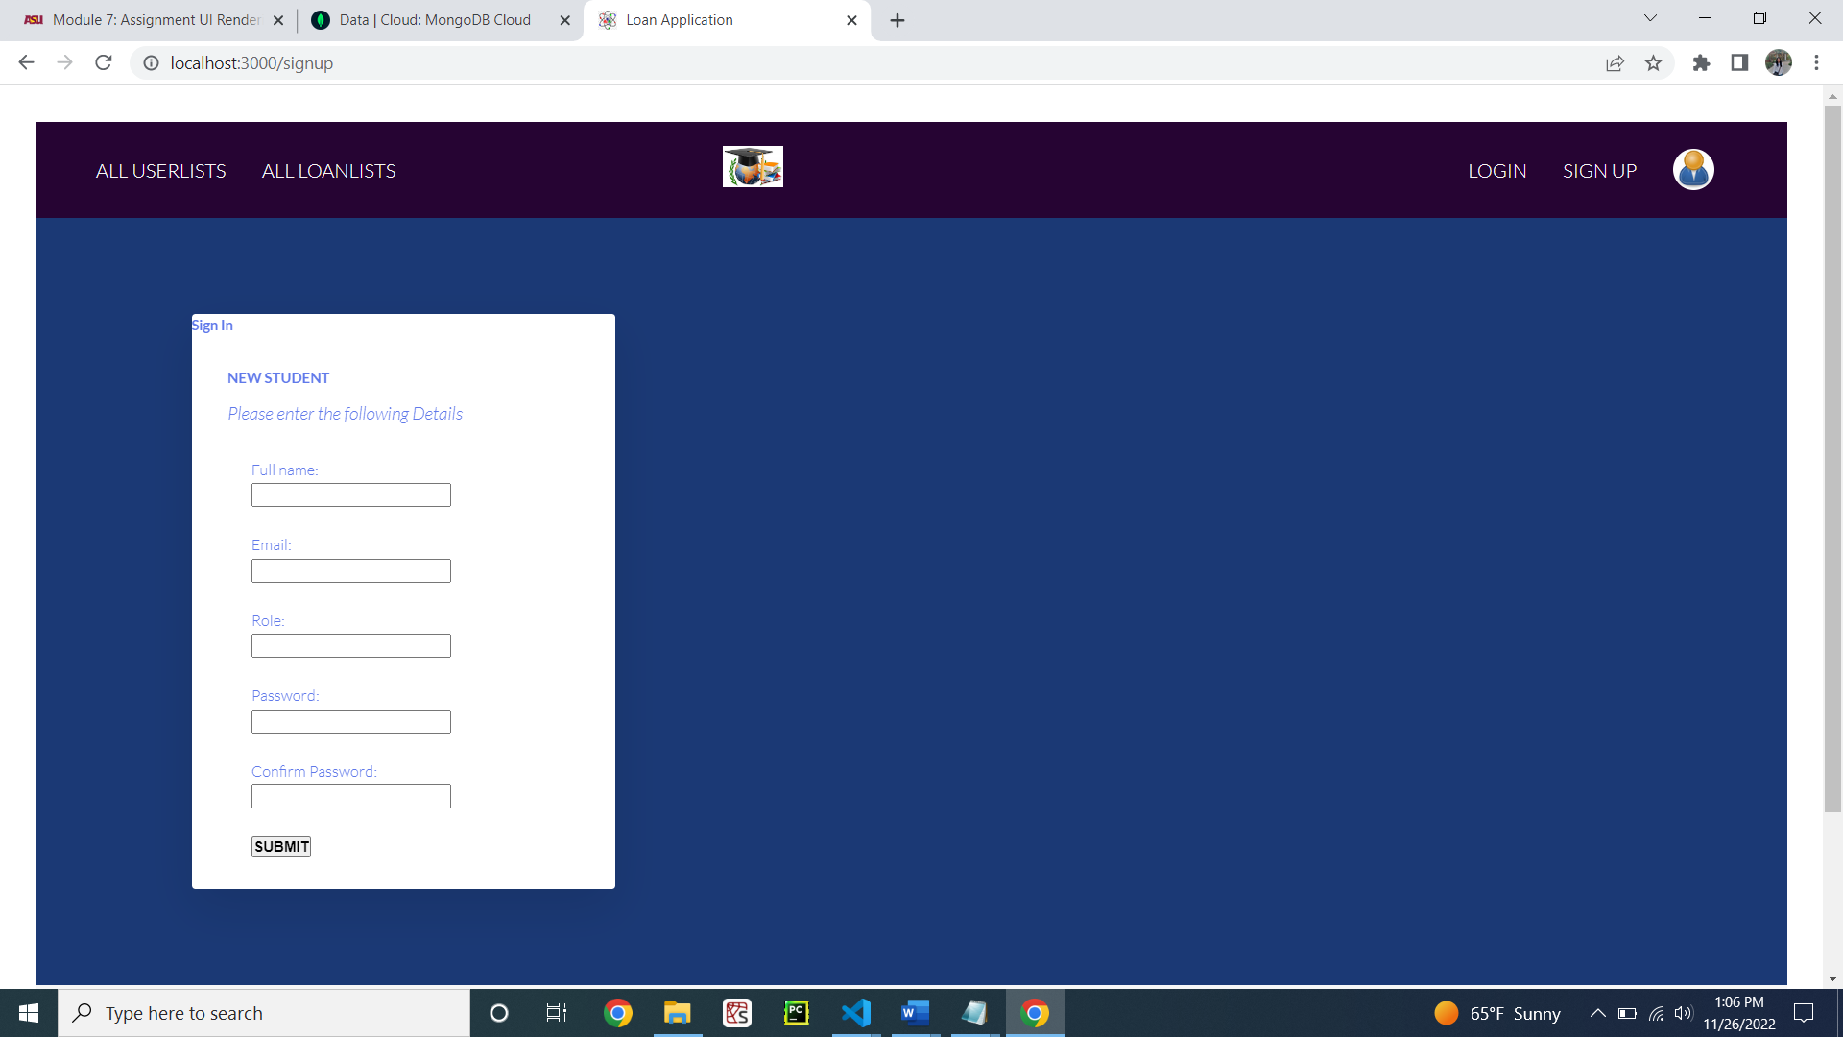

Figure 11: Sign up page

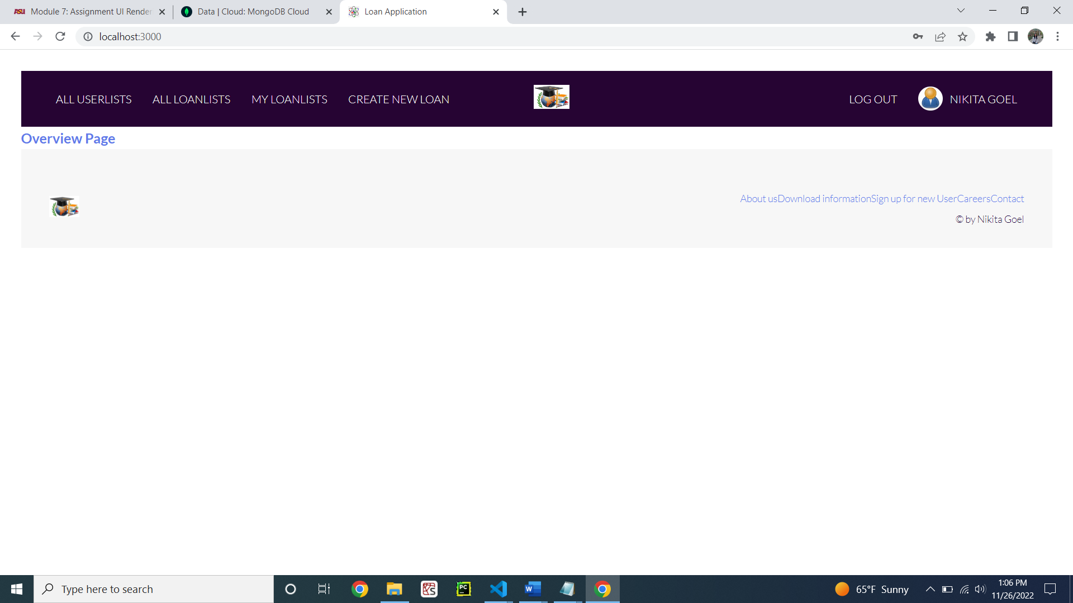

Figure 12: Sign up completed for new user

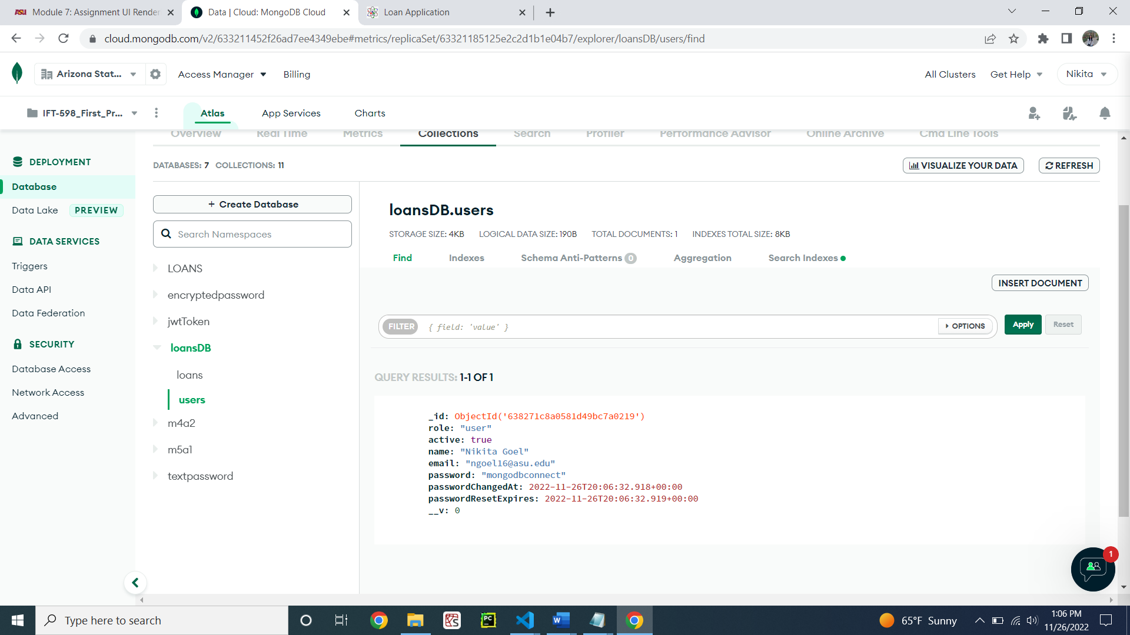

Figure 13: New user added into MongoDB successfully

**Step 2: LogIn the newly created user**

viewController.js navigating to the pug file (Figure 14)

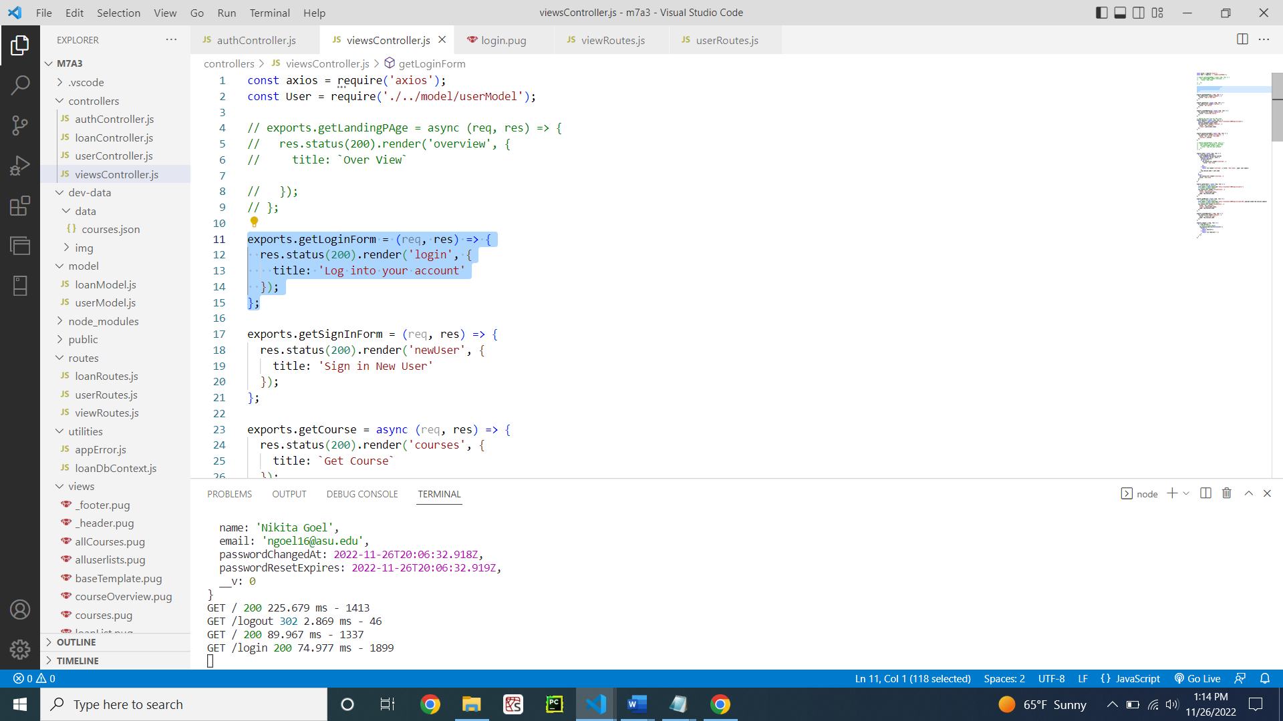

Figure 14: viewController.js for the sign in

PUG file for the login page in the UI (Figure 15)

**Code:**

extends baseTemplate

block content

    // LOGIN FORM

    main.main

      .card-container

        .card

          .card__header

            .card__details

              h4.card__sub-heading Login

              p.card__text Please enter the following Details

              .card__data

              form(action='/api/v1/users/login/' method='post')

                label(for='email') Email:

                input(type='text' id='email' name='email')

                label(for='password') Password:

                input(type='password' id='password' name='password')

                input.card__sub-heading( type='submit' value='Log In')

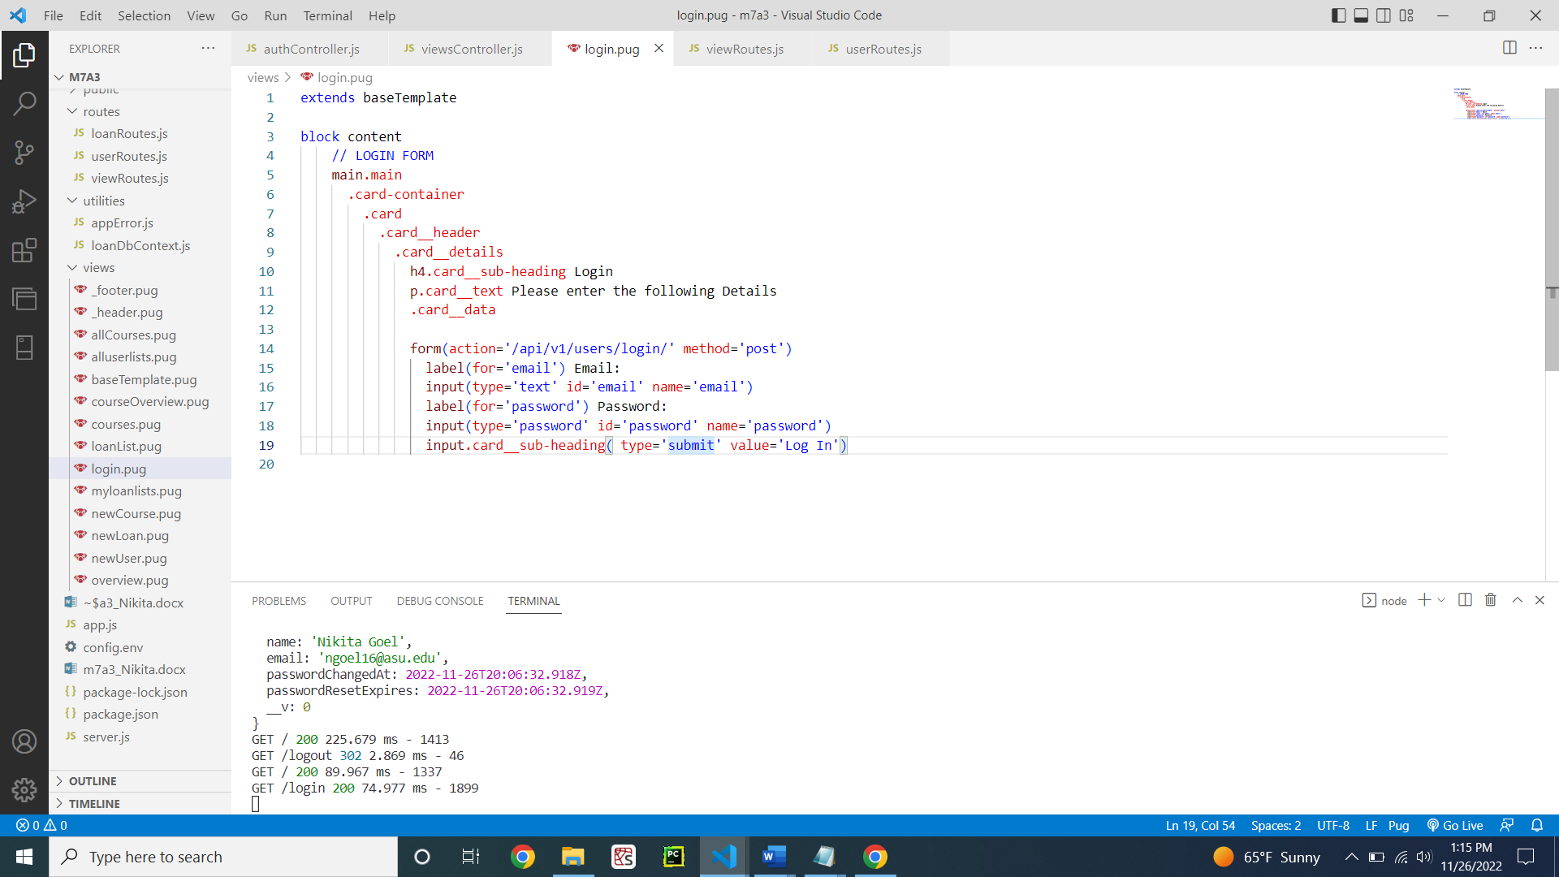

Figure 15: PUG file for the login page

viewRoutes.js for the routing to the login page (Figure 16)

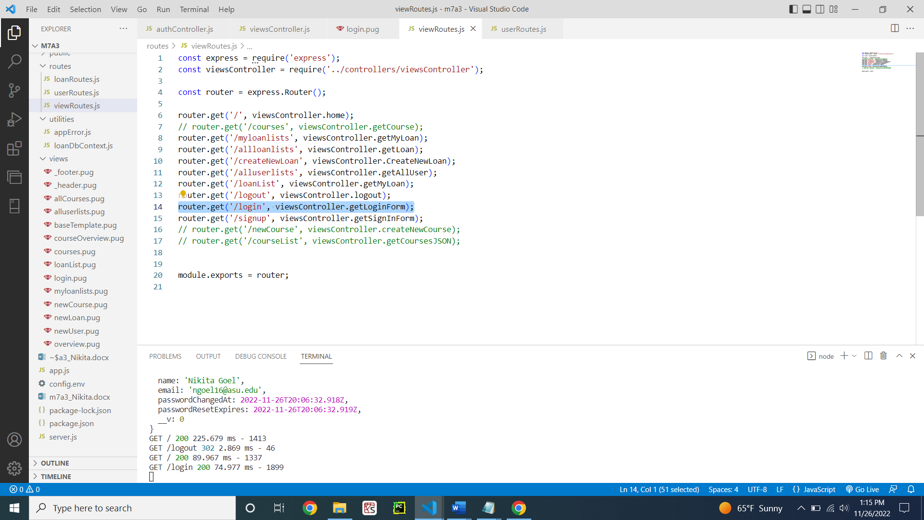

Figure 16: viewRoutes.js for the login page

userRoutes.js for calling authentication on the login page (Figure 17)

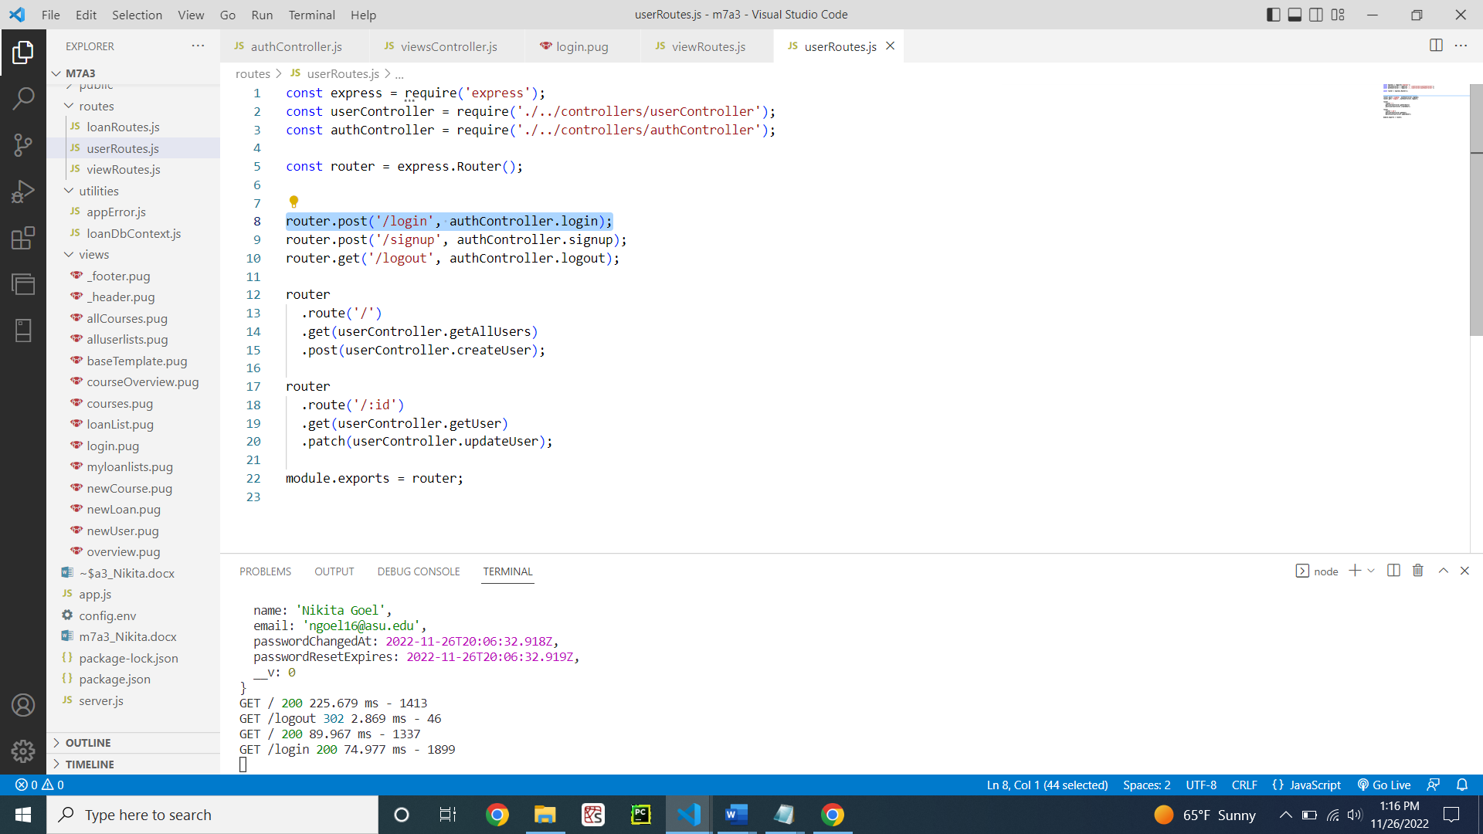

Figure 17: userRoutes.js for login page

authController.js function showing login authentication (Figure 18)

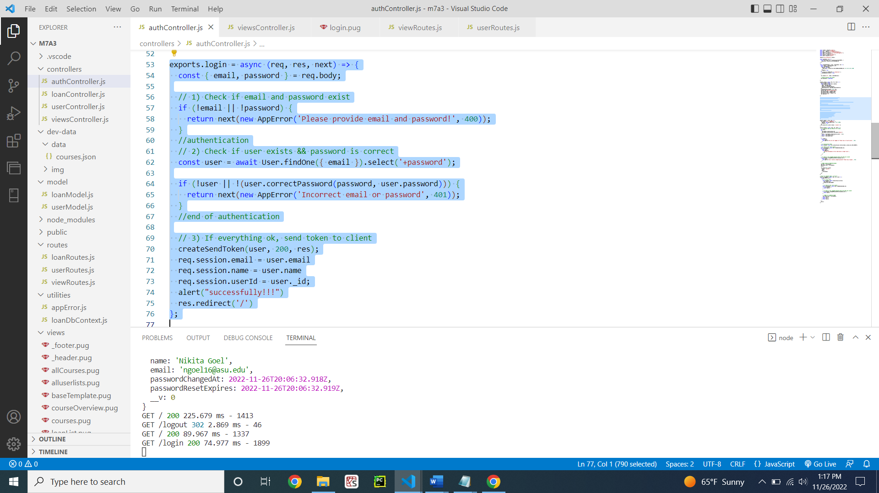

Figure 18: authController.js for the login of user

Demonstration of the login of new user created (Figure 19 - 20)

Figure 19 shows the login page when we click from overview page to login button.

Figure 20 shows the login successfully pop-up and the page has the users name.

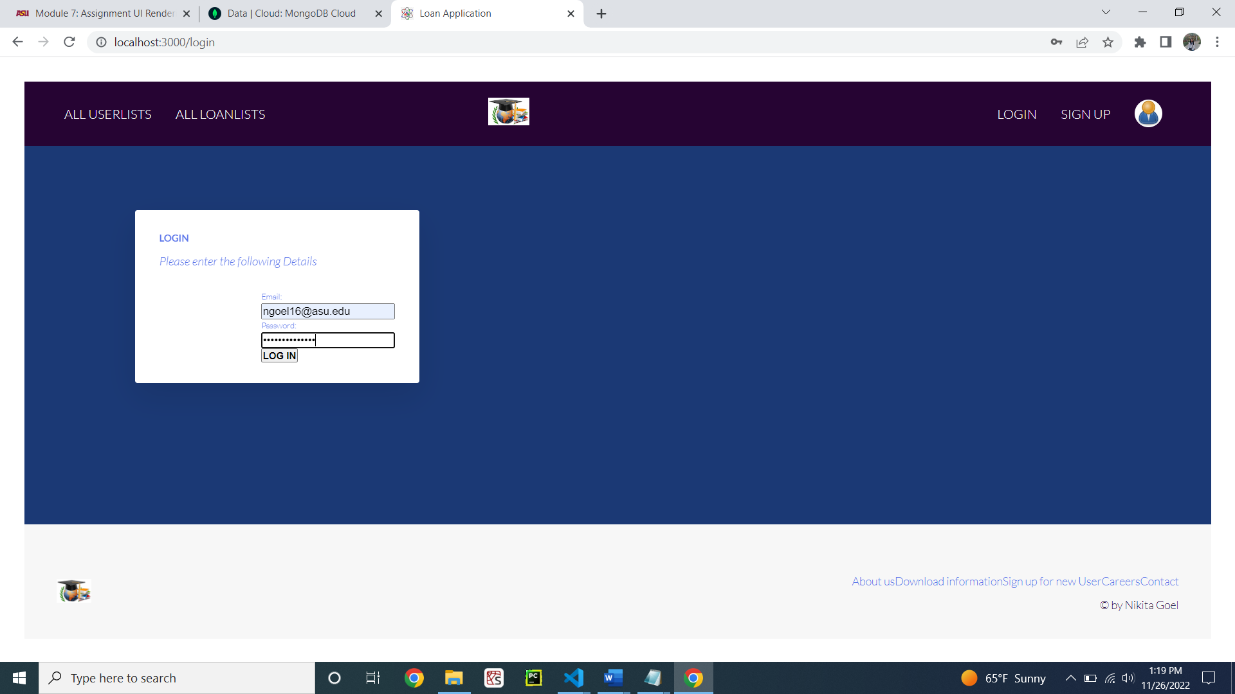

Figure 19: login page

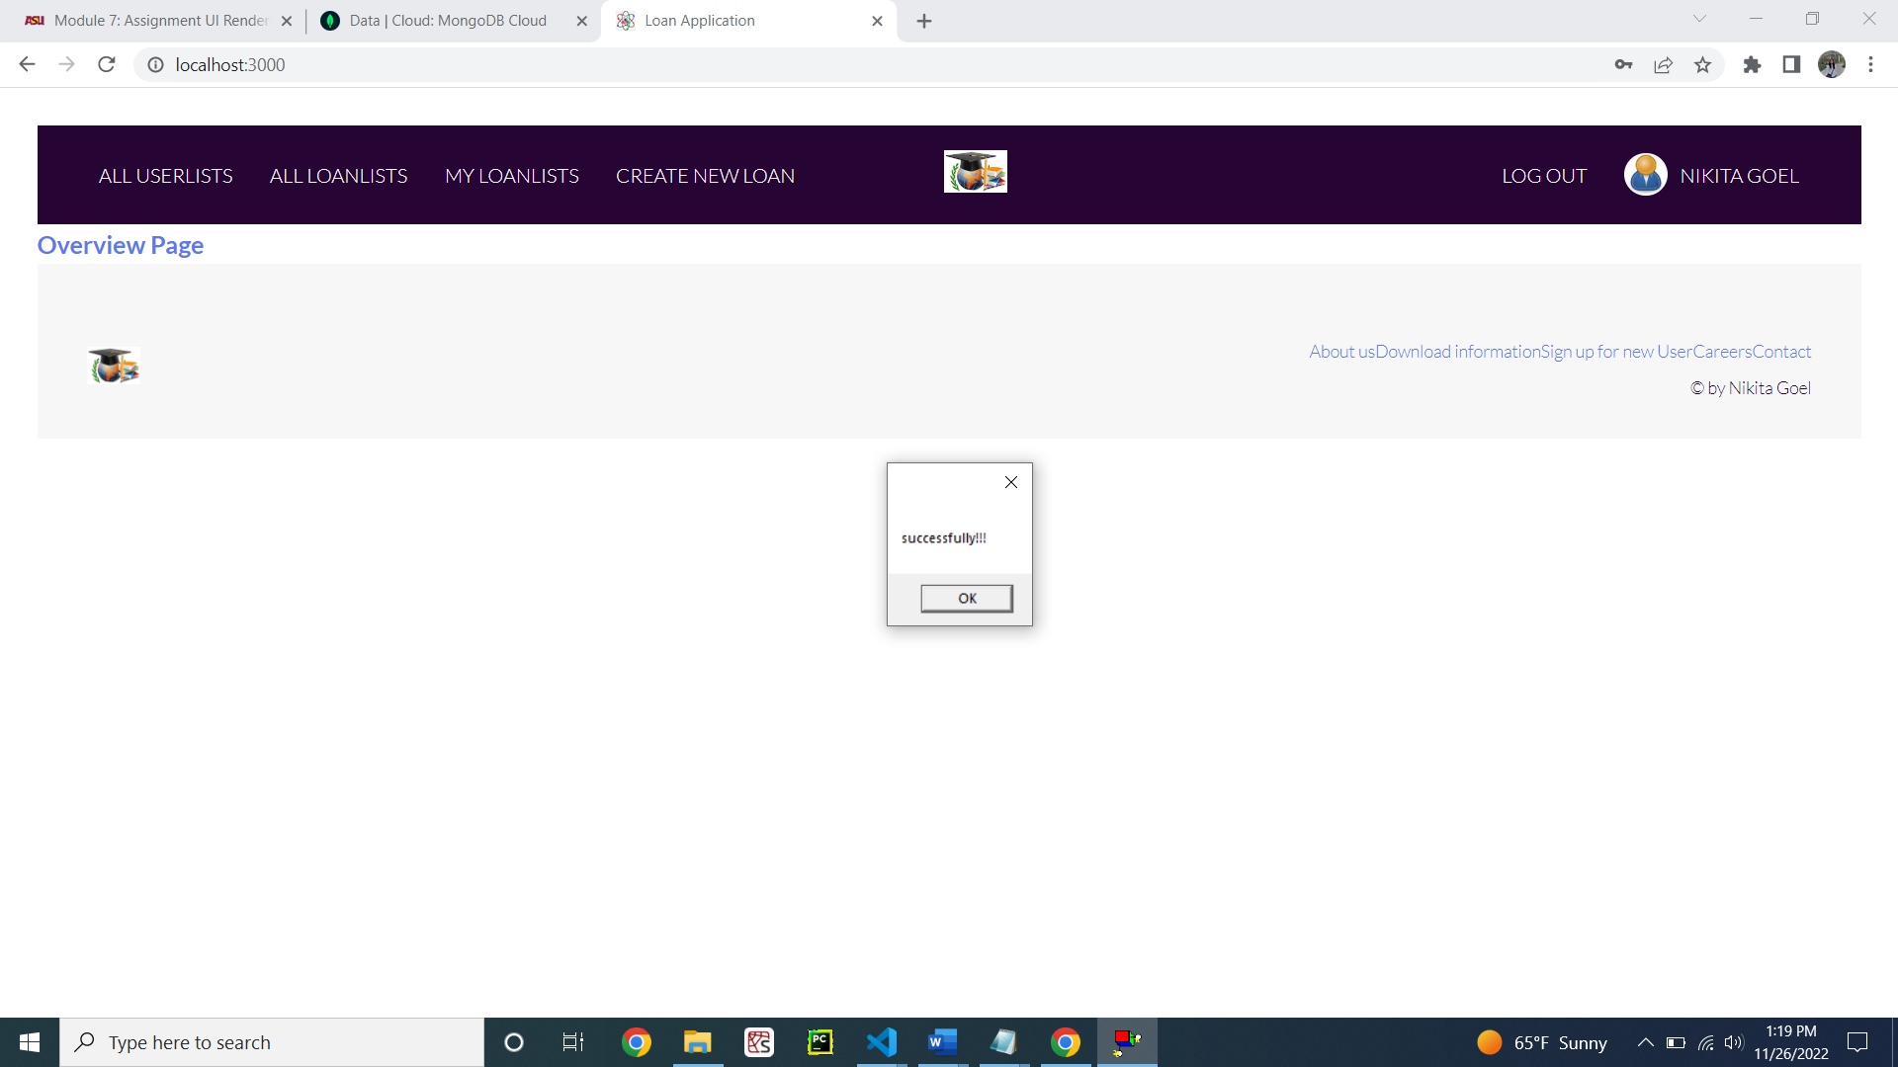

Figure 20: Login successfully with the user’s name on the top right corner

**Step 3: The listing of loans**

PUG file for creating a new loan (Figure 21)

**Code:**

extends baseTemplate

block content

  h1 Create new loan

  main.main

    .card-container

      .card

        .card__header

          h3.heading-tertirary

            span Create a new loan

        .card__details

          h4.card__sub-heading New Loan information

          p.card__text

          |   Please enter the following Details

          .card__data

            svg.card__icon

              use(xlink:href='img/icons.svg#icon-map-pin')

            form(action='/api/v1/loans/' method='post')

              label(for='name') Name:

              input#name(type='text' name='name')

              br

              br

              label(for='loanType') loanType:

              input#loanType(type='loanType' name='loanType')

              label(for='startDate') startDate:

              input#startDate(type='text' name='startDate')

              br

              br

              label(for='loanTermYears') loanTermYears:

              input#loanTermYears(type='text' name='loanTermYears')

              br

              br

              label(for='phoneNumber') Phone Number:

              input#phoneNumber(type='text' name='phoneNumber')

              br

              br

              label(for='loanAmount') Amount:

              input#loanAmount(type='text' name='loanAmount')

              label(for='interest') interestRate:

              input#interest(type='text' name='interest')

              br

              br

              input.card__sub-heading(type='submit' value='Submit')

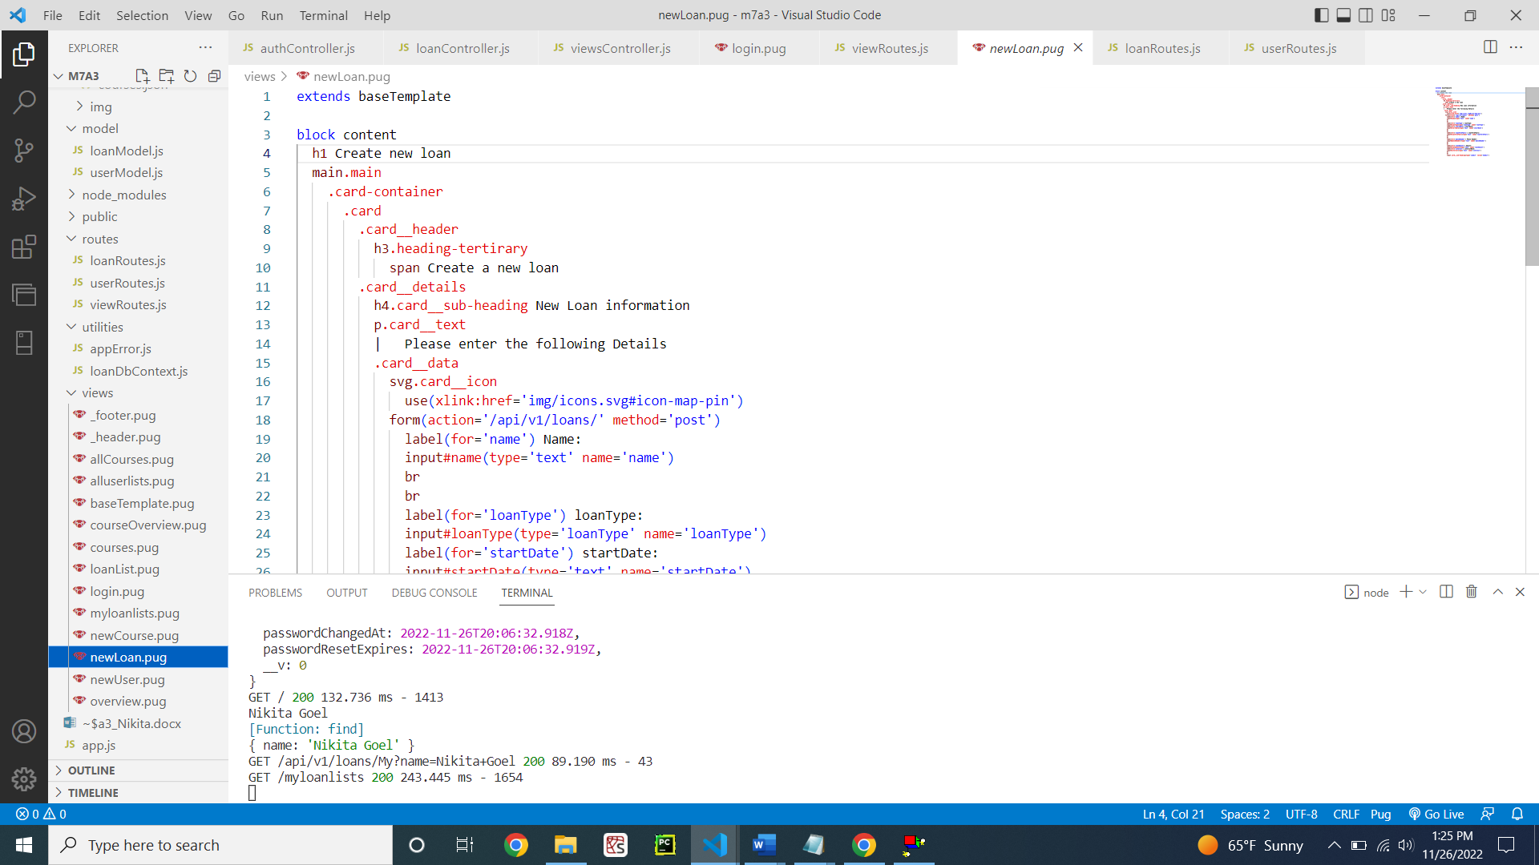

Figure 21: newLoan.pug

viewRoute.js for users loan list (Figure22)

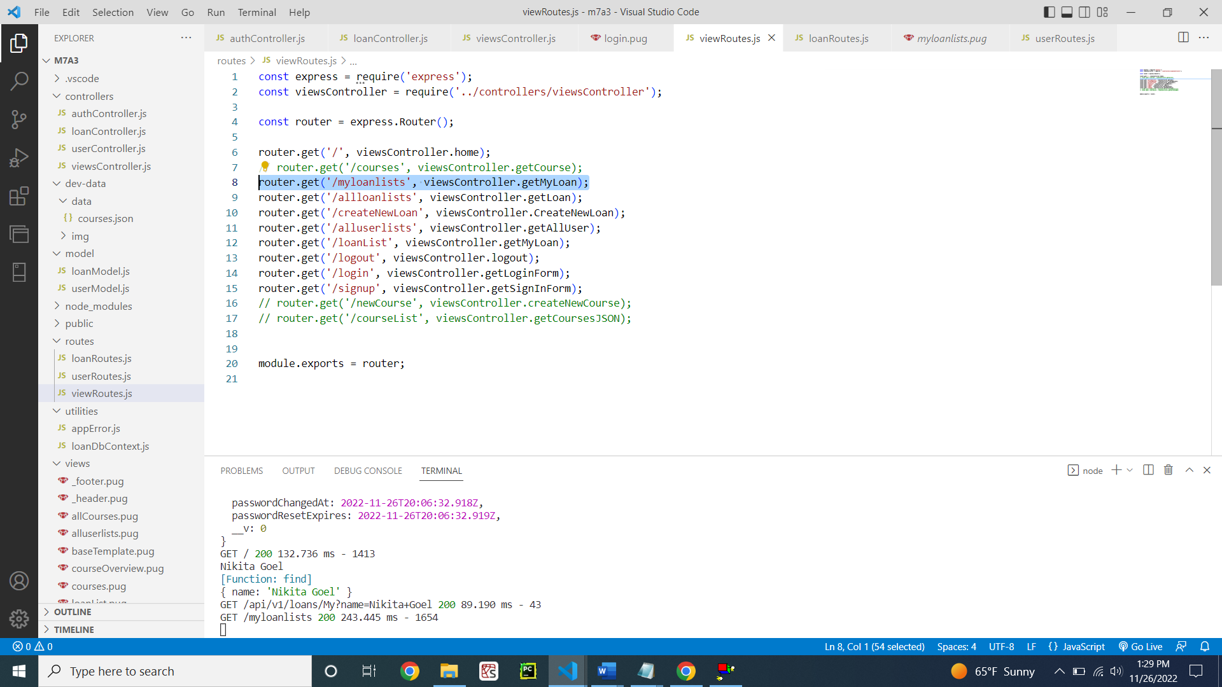

Figure 22: viewRoutes.js for users loan list

viewController.js hitting the loan routes for showing the list of loans user has (Figure 23)

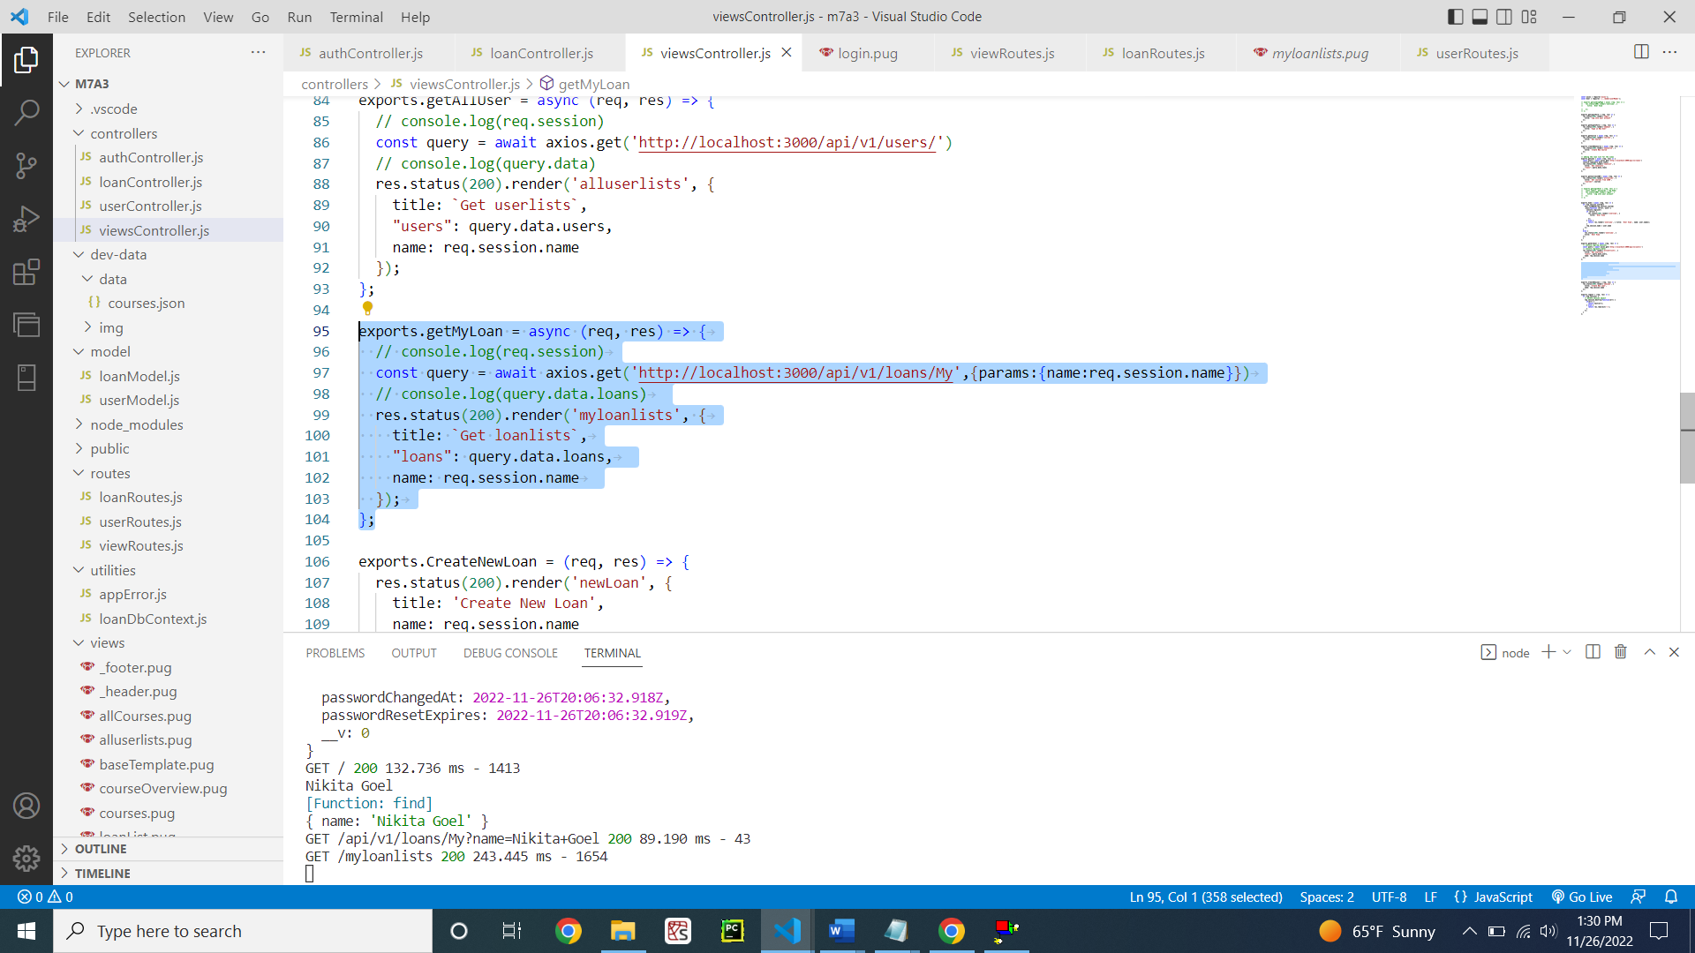

Figure 23: viewController.js

LoanRoutes.js for showing user loans (Figure 24)

**Code:**

const express = require('express');

const loanController = require('../controllers/loanController');

const router = express.Router();

router

  .route('/')

  .get(loanController.getAllLoans)

  .post(loanController.createLoan, function(req, res){

    res.redirect('/');

});

router

  .route('/My')

  .get(loanController.getMyLoans)

  // .post(loanController.createLoan);

router

  .route('/:id')

  .get(loanController.getloan)

module.exports = router;

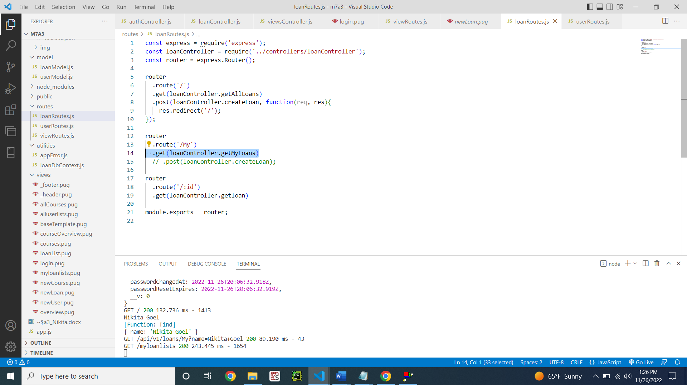

Figure 24: loanRoutes.js

loanController.js for getting user loan list (Figure 25)

**Code:**

const Loan = require('../model/loanModel');

const APIFeatures = require('../utilities/loanDbContext');

const alert =require('alert')

exports.getAllLoans =   async (req, res) => {

  console.log(req.query.name)

  try {

    // EXECUTE QUERY

    const features = new APIFeatures(Loan.find(), req.query)

      .filter()

      .sort()

      .limitFields()

      .paginate();

    const loans = await features.query;

    // SEND RESPONSE

    res.status(200).json({

      status: 'success',

      results: loans.length,

      loans

    });

  } catch (err) {

    res.status(404).json({

      status: 'fail',

      message: err

    });

  }

};

exports.getMyLoans =   async (req, res) => {

  console.log(req.query.name)

  try {

    // EXECUTE QUERY

    const features = new APIFeatures(Loan.find(), req.query)

      .filter(Loan => Loan.Name = req.query.name)

      .sort()

      .limitFields()

      .paginate();

    console.log(Loan.find);

    console.log(req.query);

    const loans = await features.query;

    // SEND RESPONSE

    res.status(200).json({

      status: 'success',

      results: loans.length,

      loans

    });

  } catch (err) {

    res.status(404).json({

      status: 'fail',

      message: err

    });

  }

};

exports.getloan = async (req, res) => {

  try {

    const loans = await Loan.find();

    //Loan.findOne({ _id: req.params.id })

    res.status(200).json({

      status: 'success',

      results: loans.length,

      data: {

        loans

      }

    });

  } catch (err) {

    res.status(404).json({

      status: 'fail',

      message: err

    });

  }

};

exports.createLoan = async  (req, res) => {

  try {

    const newLoan = await Loan.create(req.body);

    res.redirect('/')

    // res.status(201).json({

    //   status: 'success',

    //   data: {

    //     loan: newLoan

    //   }

    // })

  } catch (err) {

    res.status(400).json({

      status: 'fail',

      message: err

    });

  }

};

exports.updateLoan = async (req, res) => {

  try {

    const loan = await Loan.findByIdAndUpdate(req.params.id, req.body, {

      new: true,

      runValidators: true

    });

    res.status(200).json({

      status: 'success',

      data: {

        loan

      }

    });

  } catch (err) {

    res.status(404).json({

      status: 'fail',

      message: err

    });

  }

};

exports.deleteLoan = async (req, res) => {

  try {

    await Loan.findByIdAndDelete(req.params.id);

    res.status(200).json({

      status: 'success',

      data: null

    });

  } catch (err) {

    res.status(404).json({

      status: 'fail',

      message: err

    });

  }

};

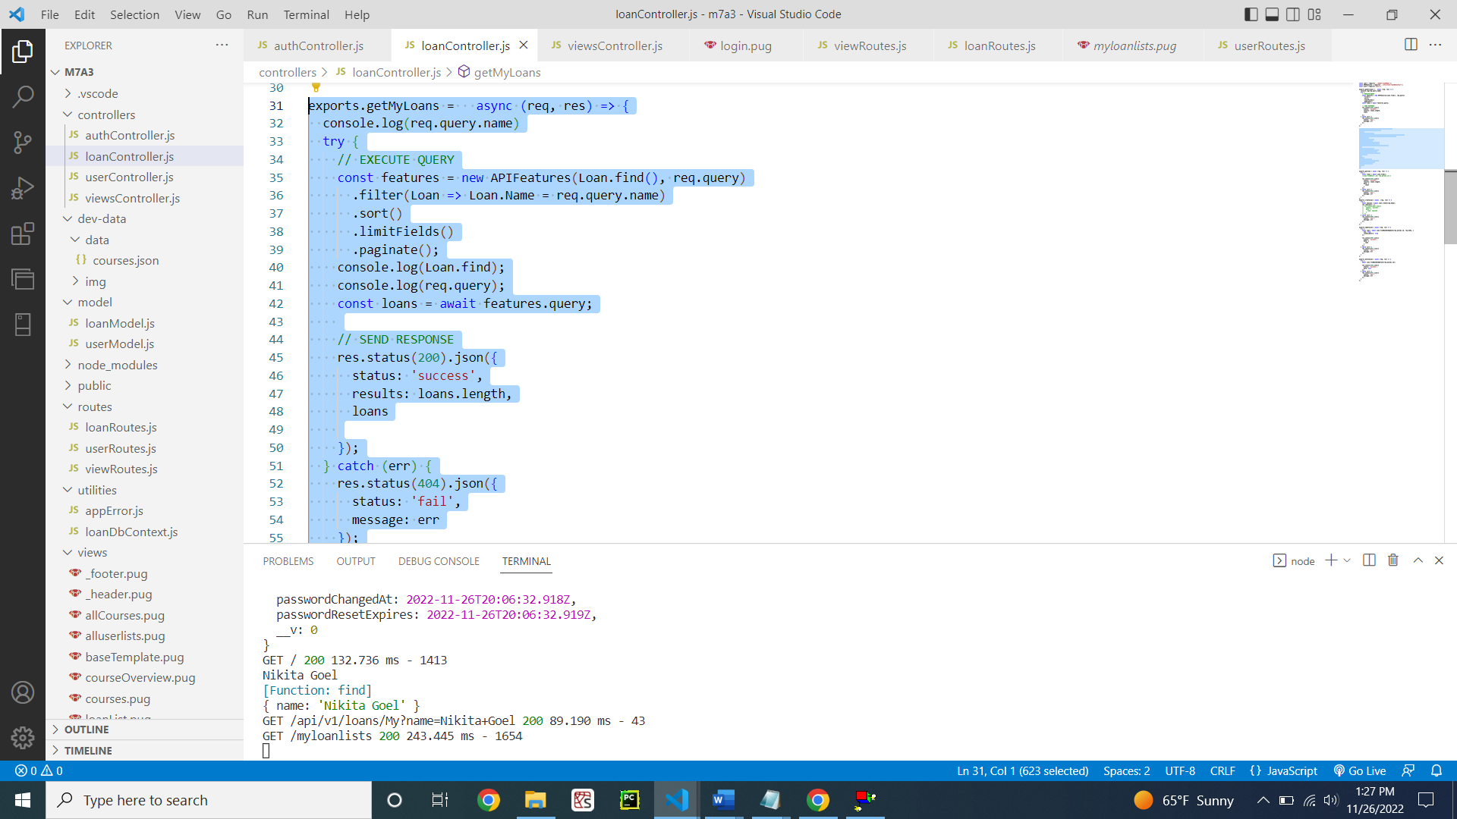

Figure 25: loancontroller.js

PUG file showing the list of loans of the user (Figure 26)

**Code:**

extends baseTemplate

block content

  h1 List of my loans

  div

    table.table-header

      thead

        tr

          th(scope='col') Name

          th(scope='col') Loan Type

          th(scope='col') Amount

          th(scope='col') Interest Rate

          th(scope='col') Loan Term Years

      tbody

        each loan in loans

          tr.table-secondary

            td=loan.name

            td=loan.loanType

            td=loan.loanAmount

            td=loan.interest

            td=loan.loanTermYears

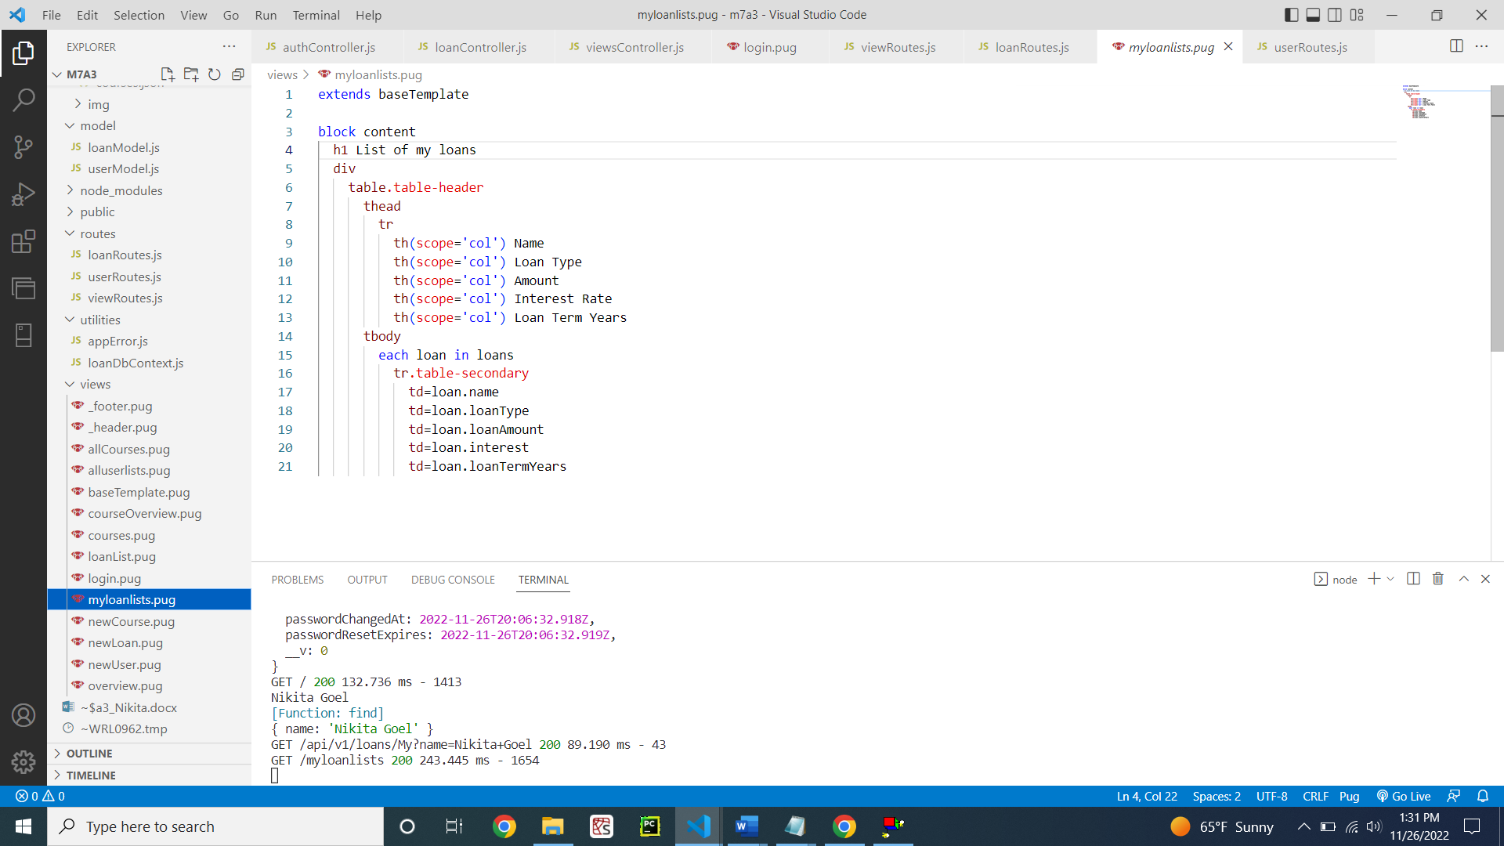

Figure 26: PUG file for listing a user’s loan

Demonstrating the creation of loan by the user (Figure 27 – 28)

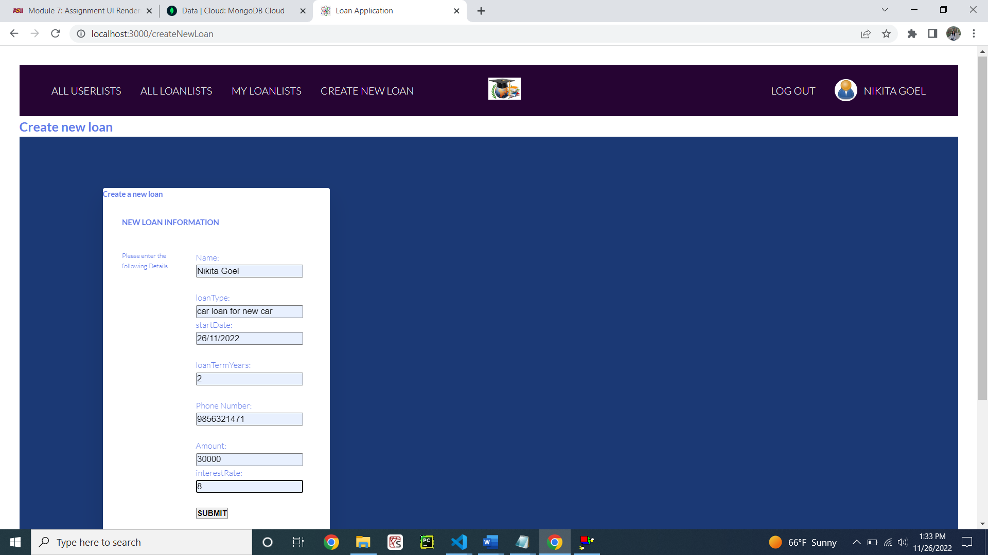

Figure 27: Creating a new loan for the user

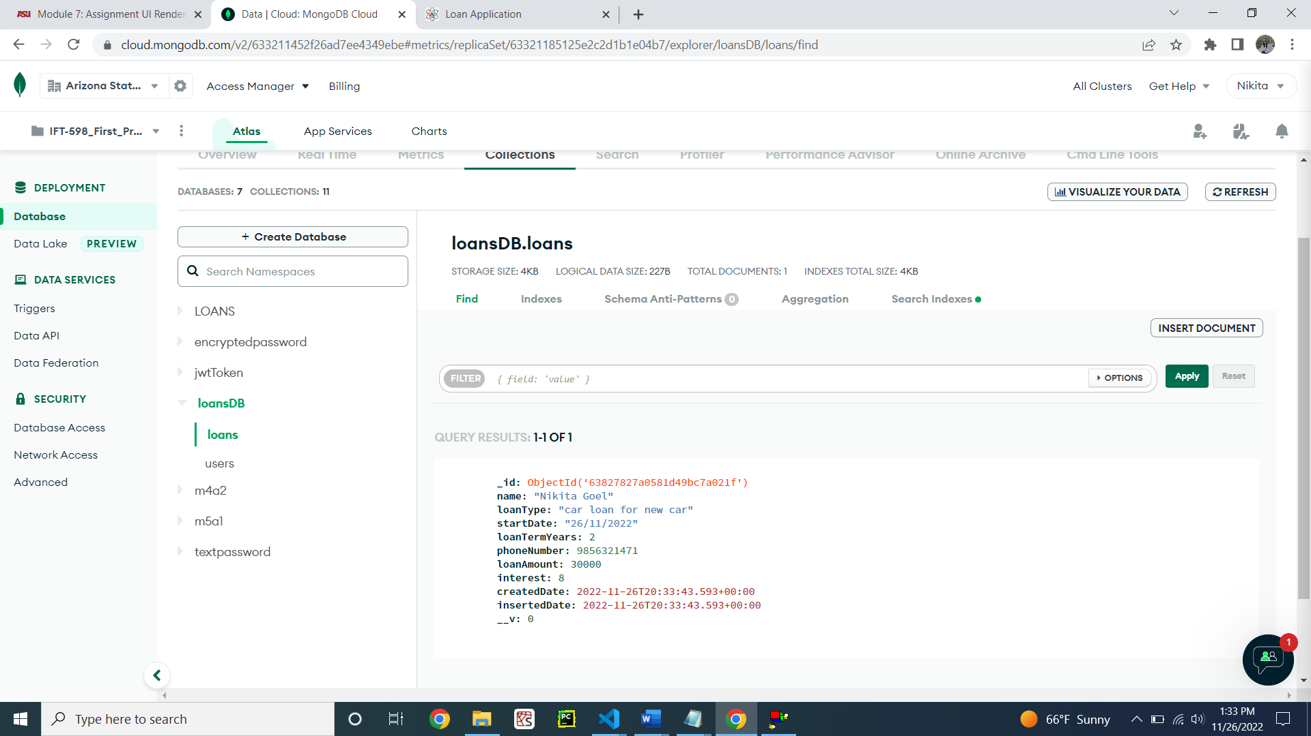

Figure 28: New loan gets added for that user

Demonstrating the listing of loan particular to that user (Figure 29)

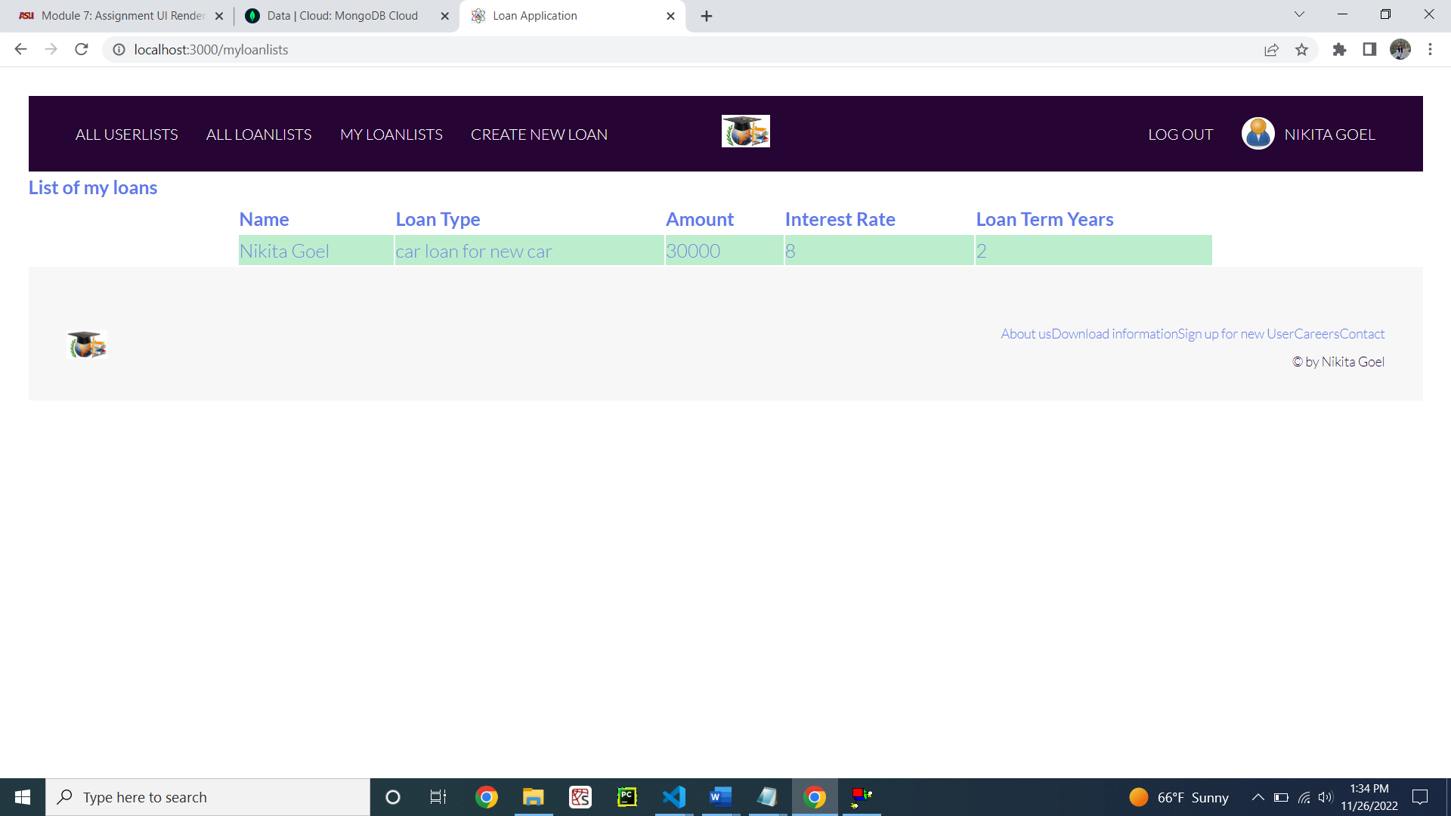

Figure 29: Hitting MYLOANLISTS and obtaining the result

**Step 4: The MongoDB Atlas Database**

Adding more users in the users collection in Mongo DB (Figure 30)

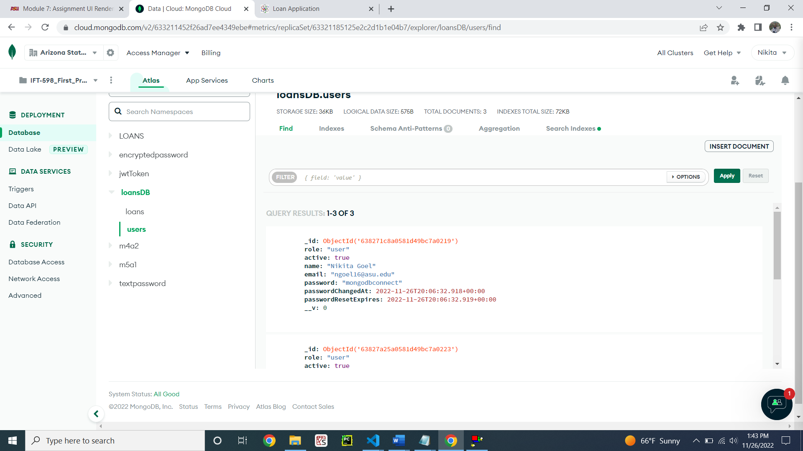

Figure 30: New users added in user collection

Adding more loans for these users (Figure 31)

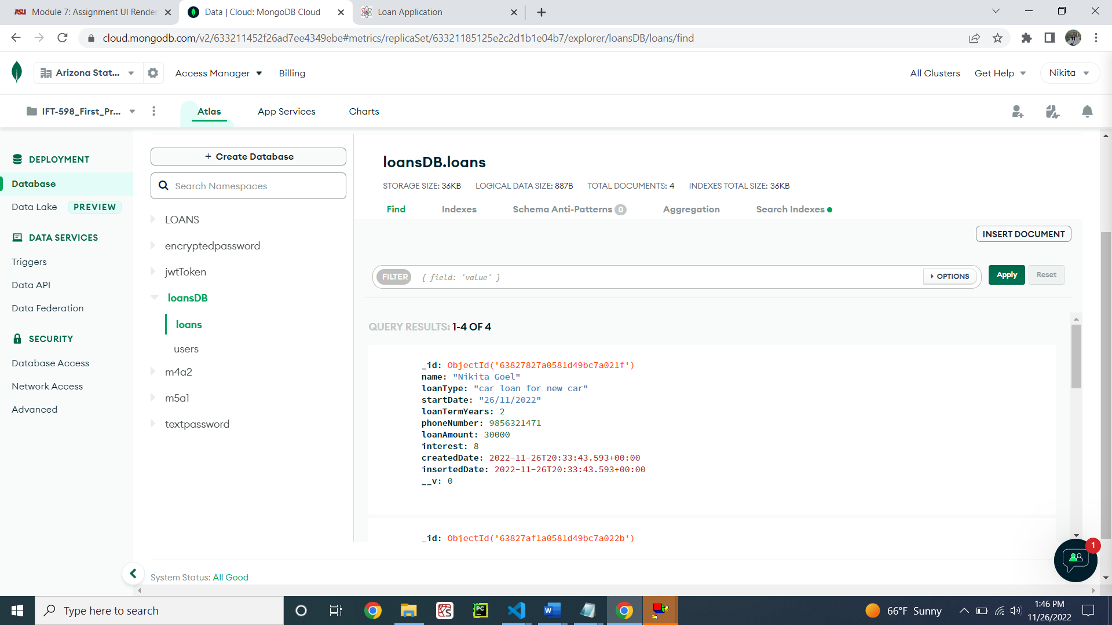

Figure 31: New loans added into the loans collection

**Step 5: The users list of users**

viewRoutes.js showing the route for listing all users (Figure 32)

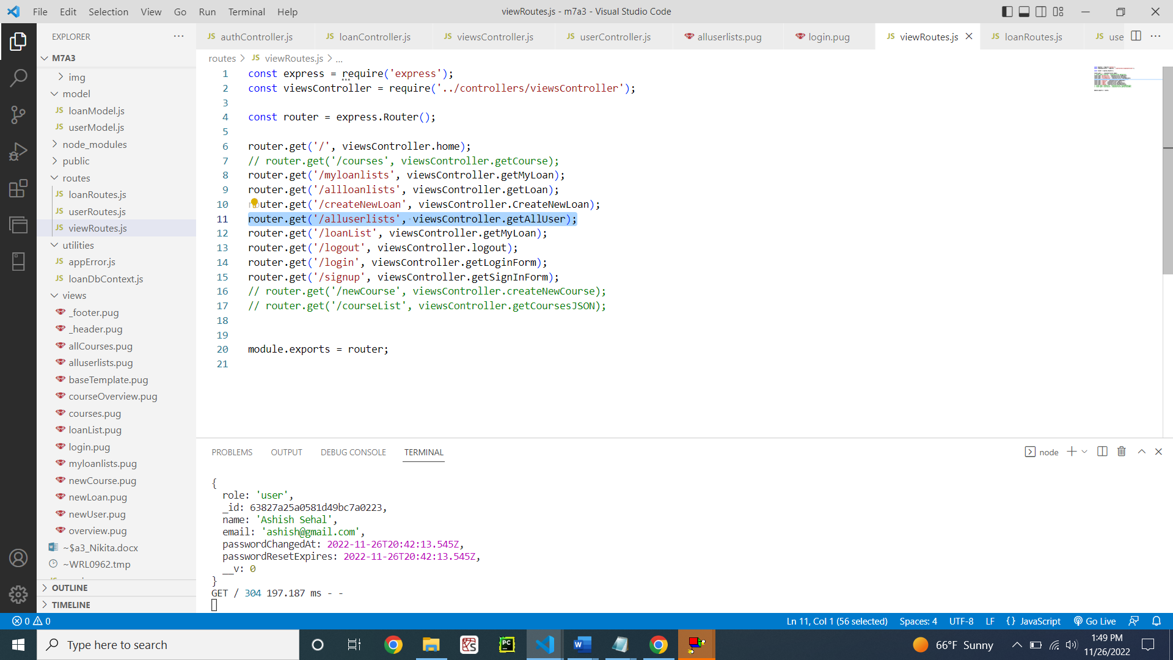

Figure 32: viewRoutes.js for all listing users

viewController.js for getting the user route (Figure 33)

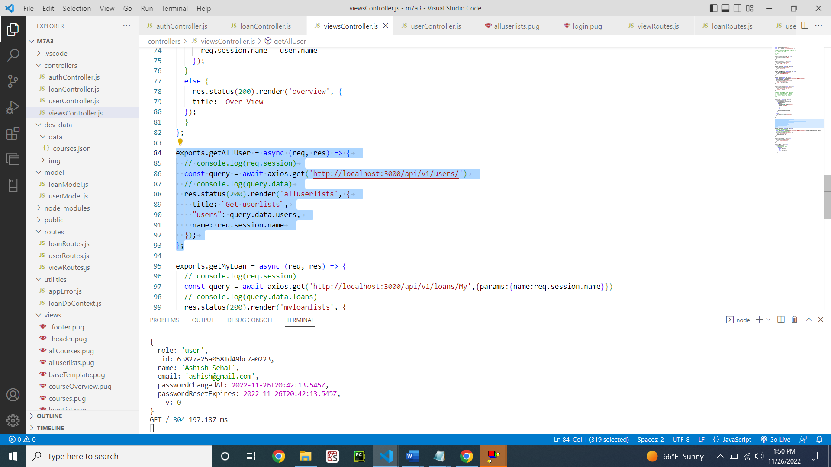

Figure 33: viewsController.js for getting the user list

userRoutes.js for user Controller function (Figure 34)

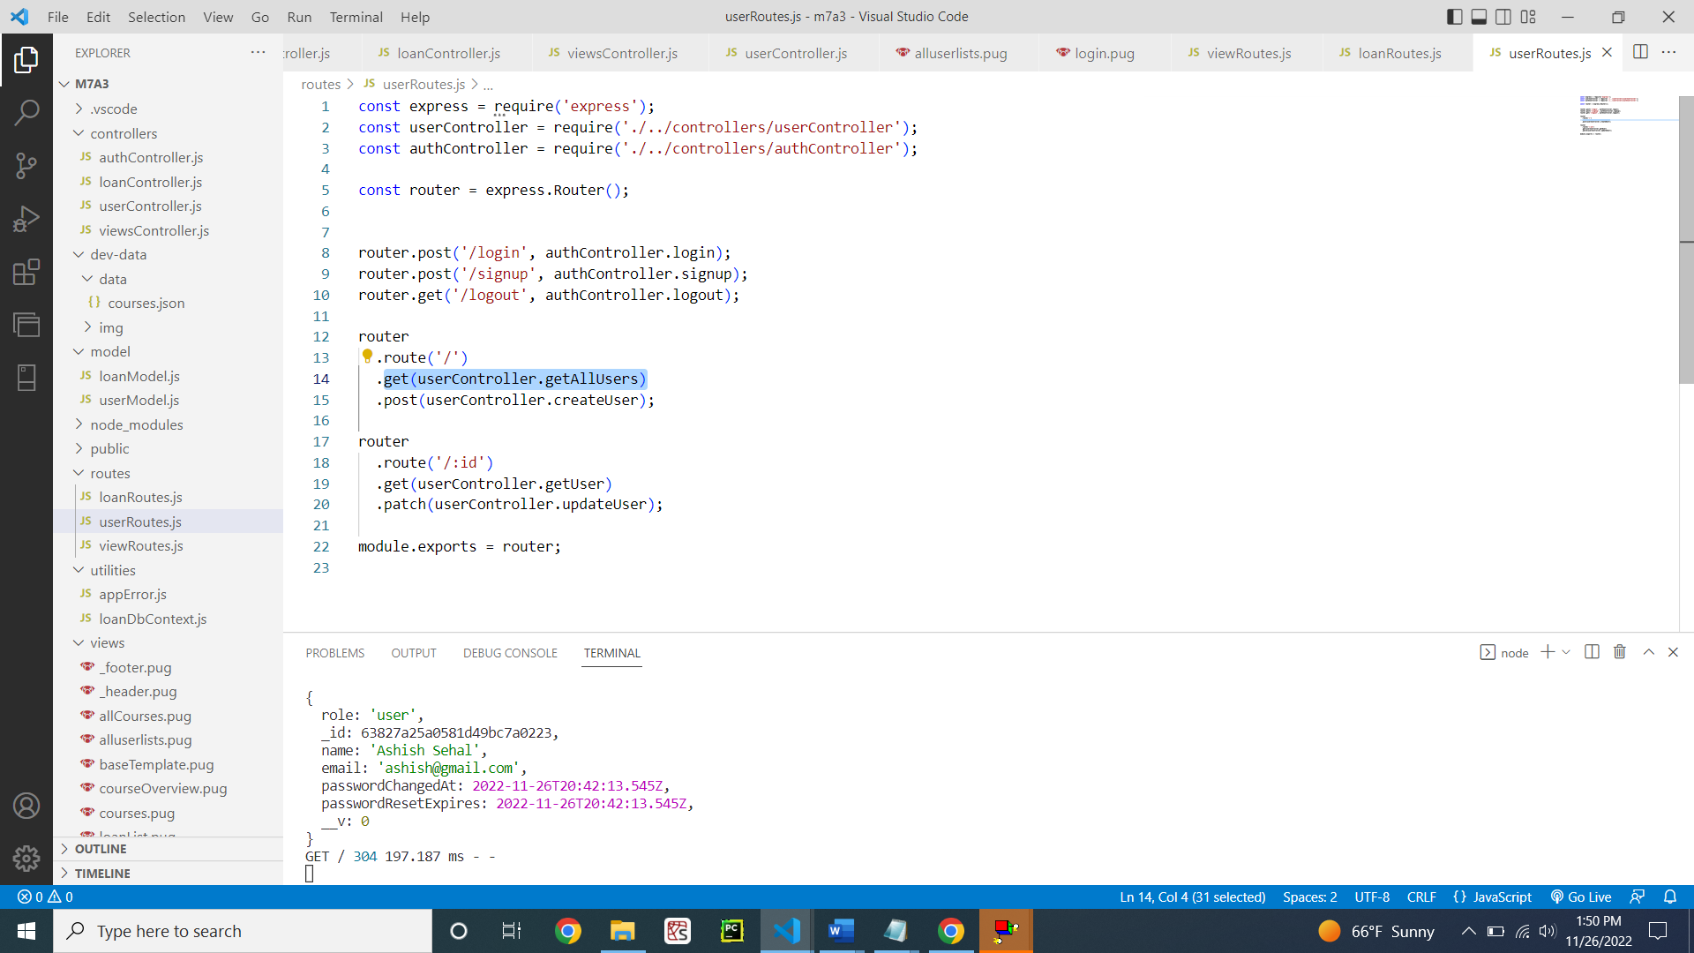

Figure 34: userRoutes.js for getting all users

userController.js for all users (Figure 35)

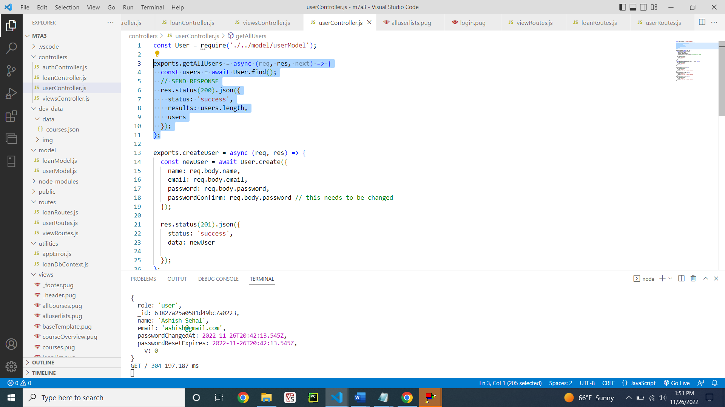

Figure 35: userController.js

PUG file for listing all users (Figure 36)

**Code:**

extends baseTemplate

block content

  h1 This is user lists Overview

  div

    table.table-header

      thead

        tr

          th(scope='col') name

          th(scope='col') email

          th(scope='col') role

      tbody

        each user in users

          tr.table-secondary

            td=user.name

            td=user.email

            td=user.role

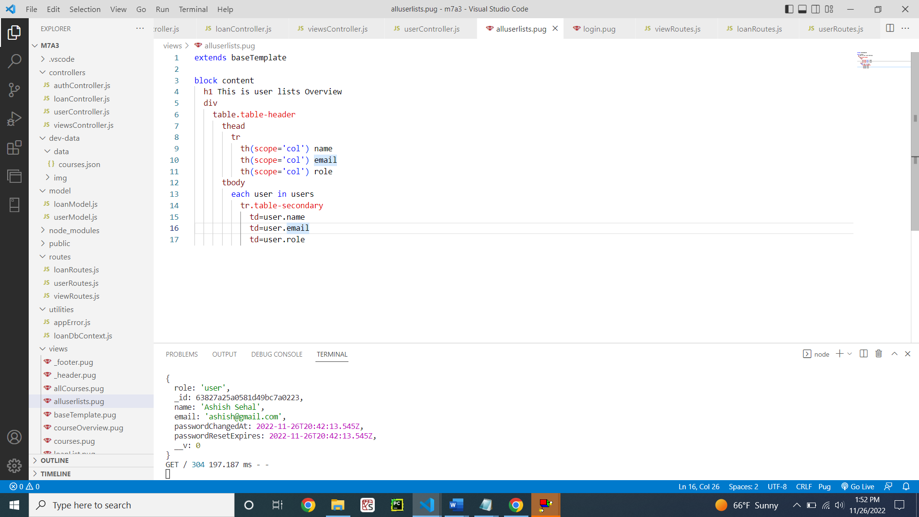

Figure 36: alluserlists.pug file

Demonstrating the listing of all users (Figure 37)

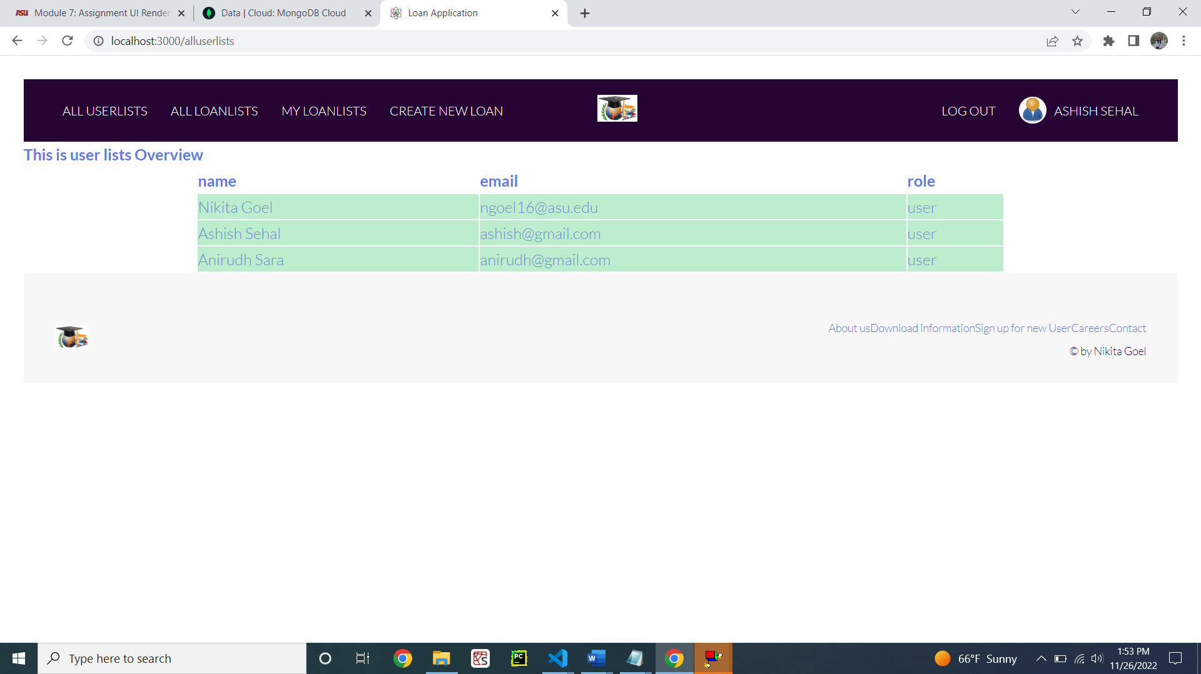

Figure 37: Listing all the users using the ALLUSERLISTS button

**Step 6: The loans**

viewRoutes.js showing the get all loan route (Figure 38)

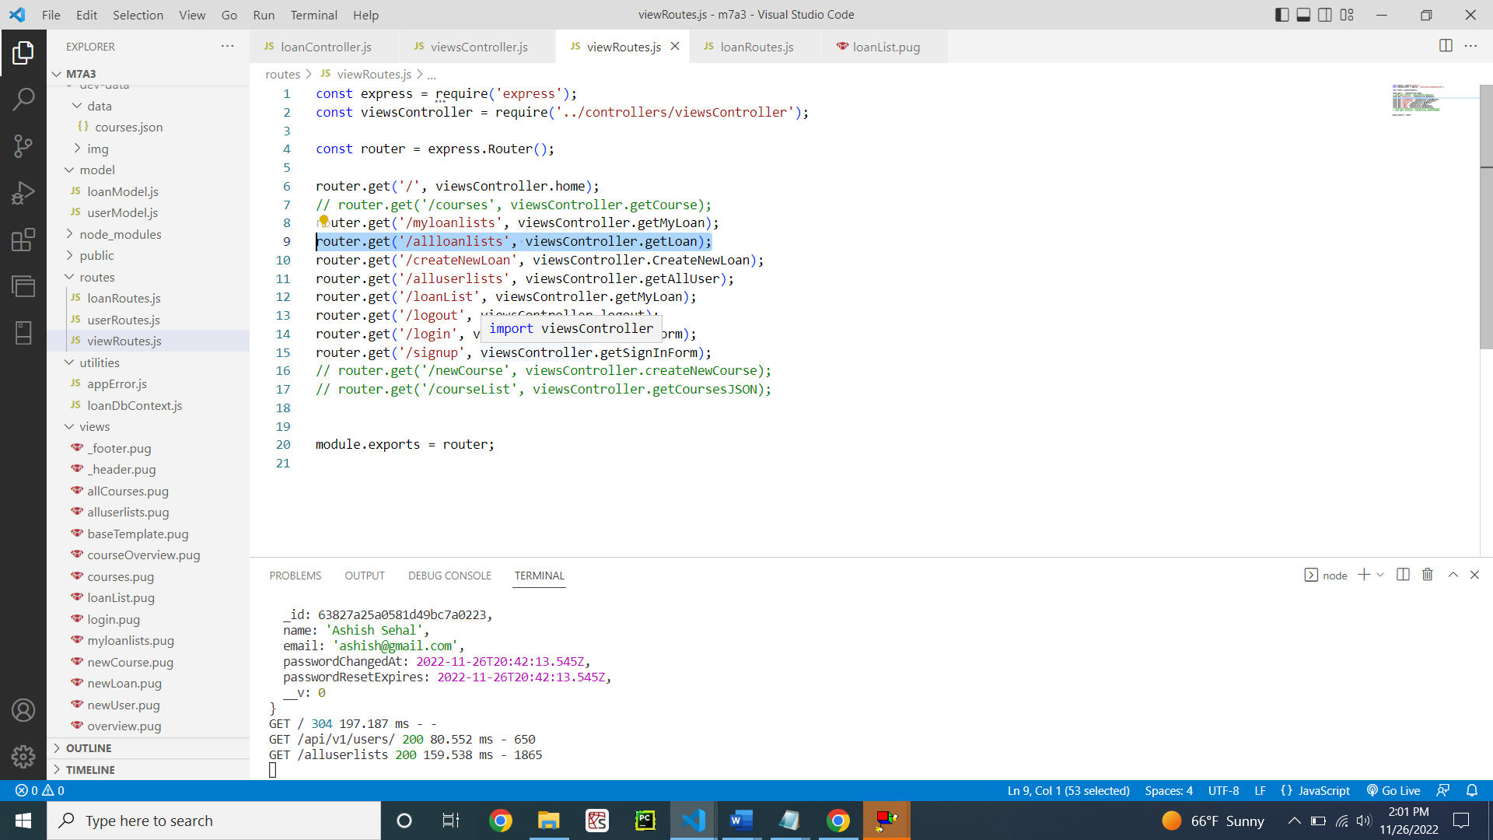

Figure 38: viewRoutes.js

viewController.js file showing the functionality when the route is called (Figure 39)

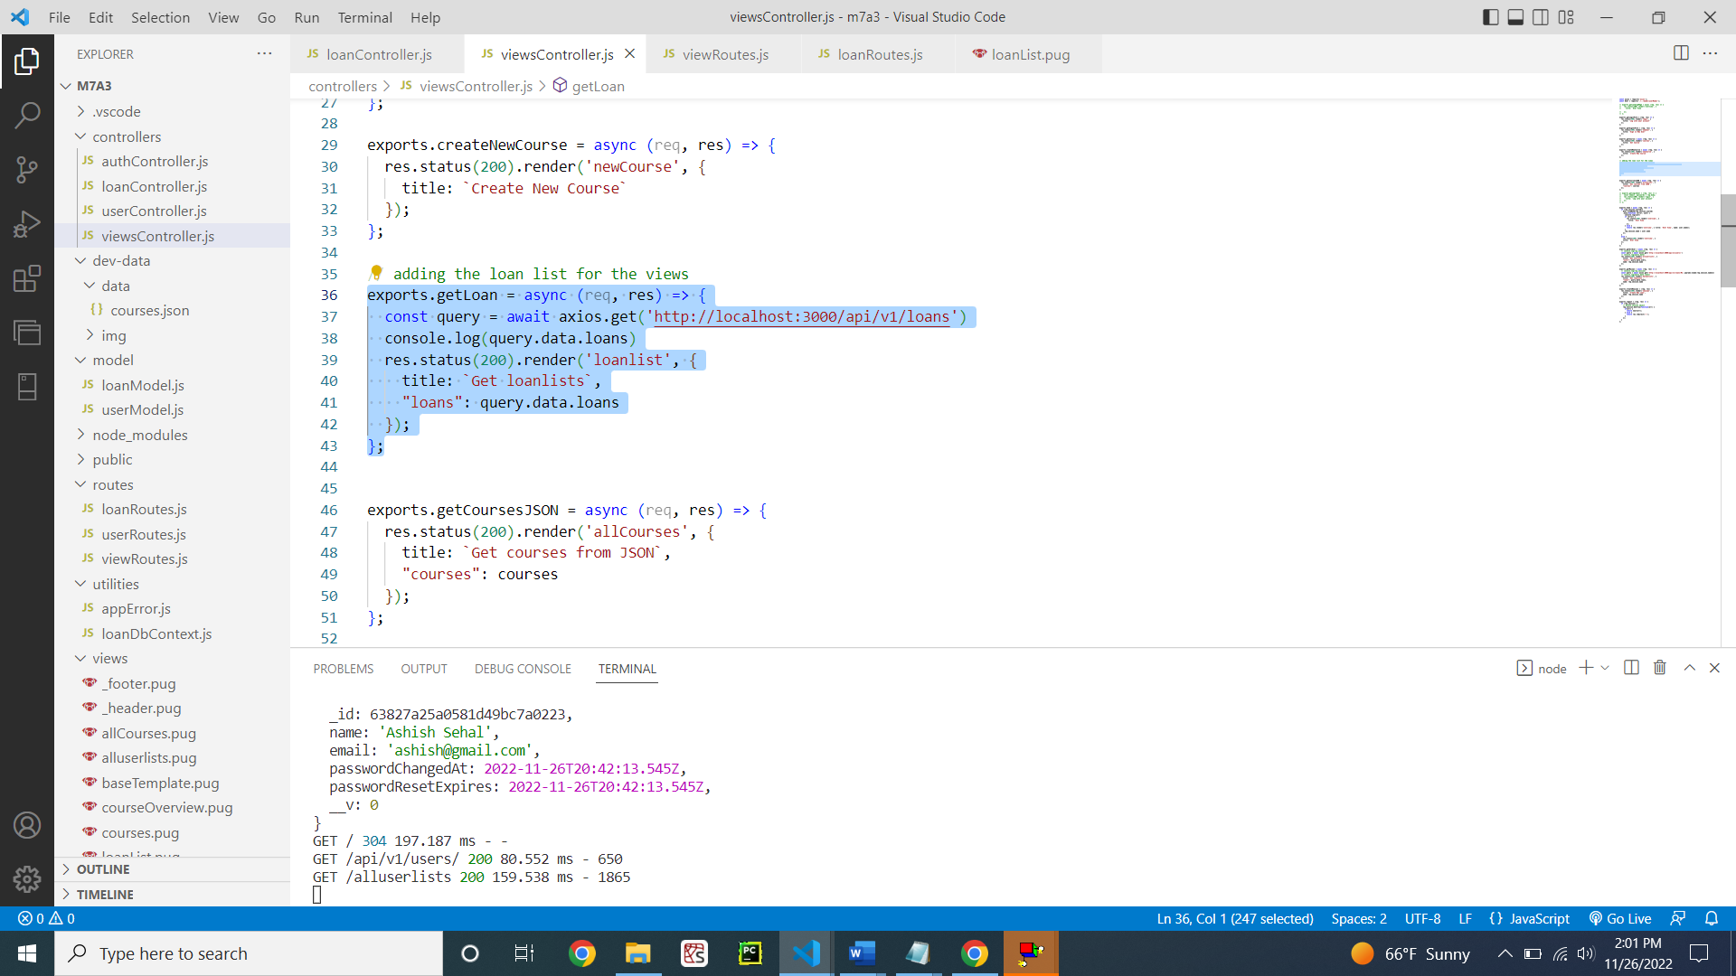

Figure 39: viewController.js

loanRoute.js file showing which route will get all the loans (Figure 40)

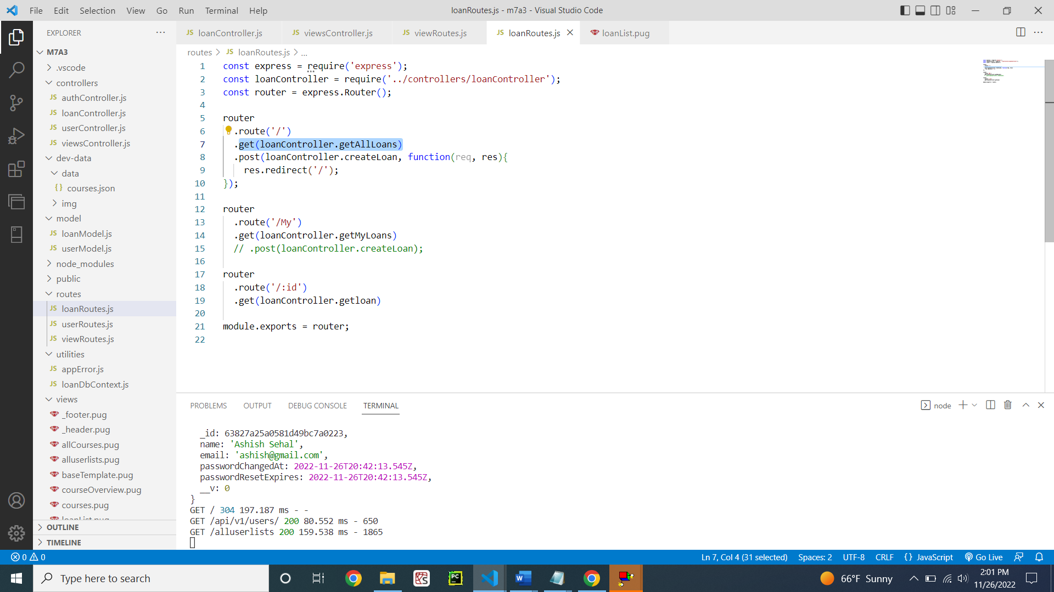

Figure 40: loanRoutes.js

loanController.js file showing the functionality to implement for bringing all the loans (Figure 41)

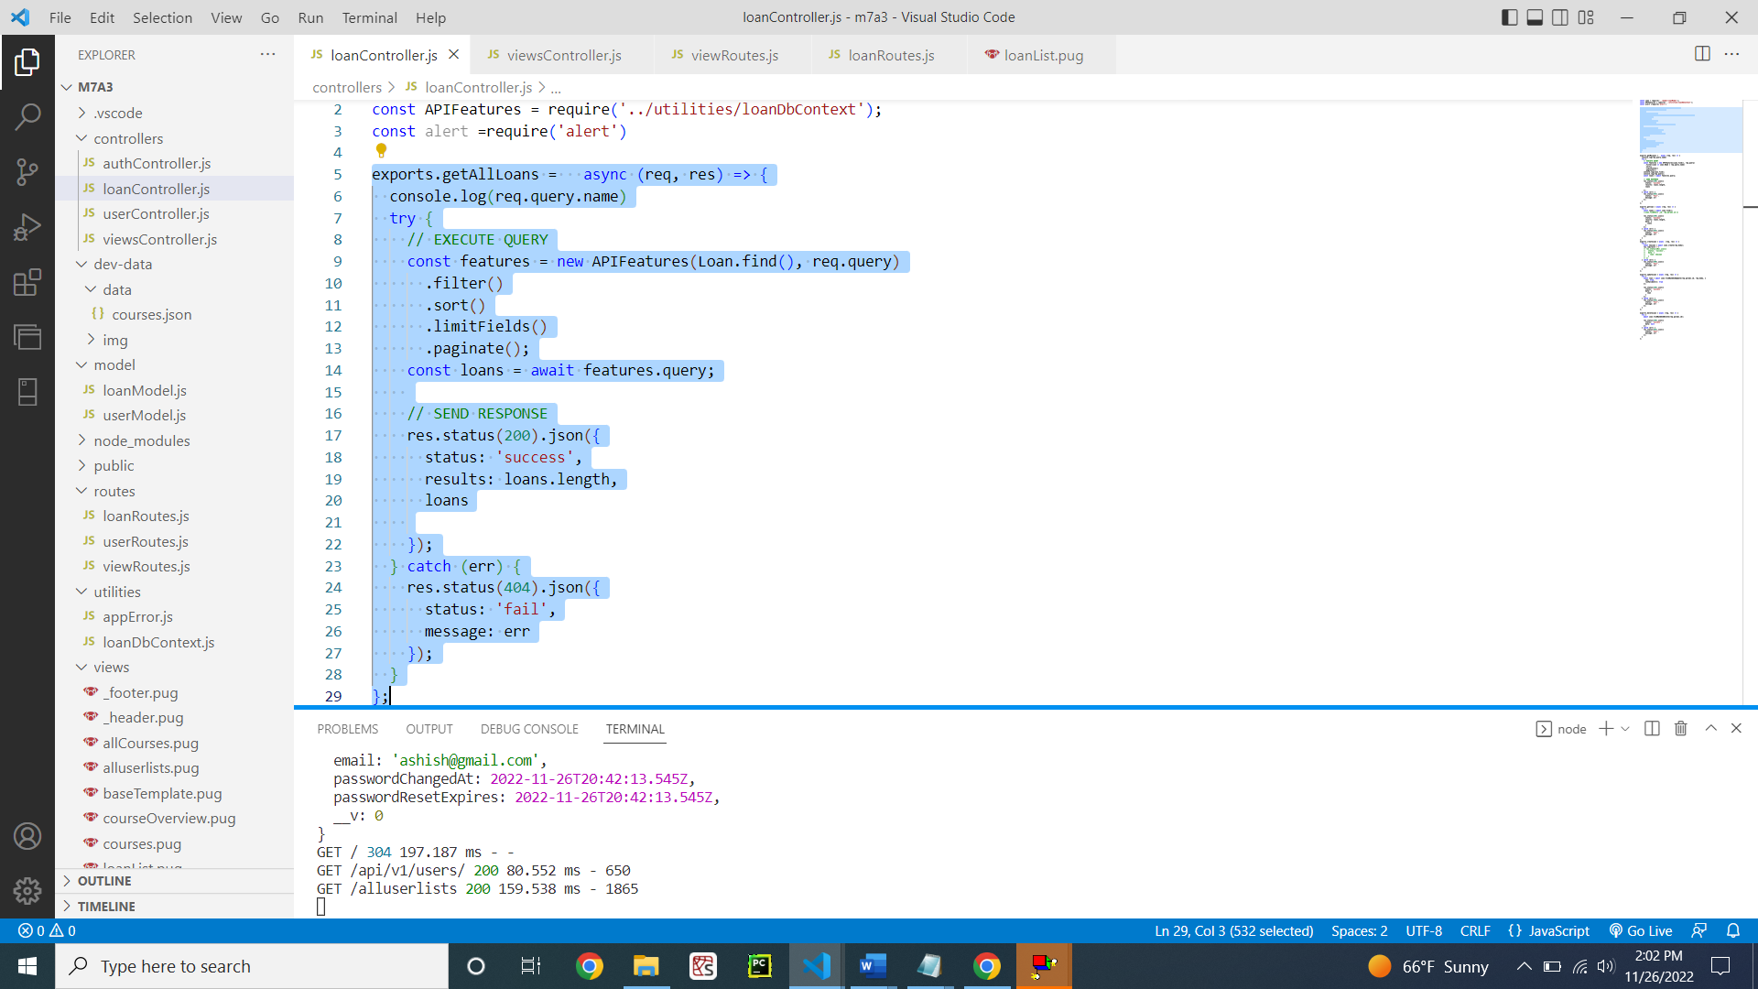

Figure 41: loansController.js

PUG File for showing the UI of all loan list (Figure 42)

**Code:**

extends baseTemplate

block content

  h3.heading-primary

    span List of Loans

  table.table-header

    thead

      tr

        th(scope='col') Name

        th(scope='col') Type of Loan

        th(scope='col') Phone Number

        th(scope='col') Amount

        th(scope='col') Interest Rate (%)

        th(scope='col') Term (Yrs)

    tbody

      each loan in loans

        tr.table-secondary

          td=loan.name

          td=loan.loanType

          td=loan.phoneNumber

          td=loan.loanAmount

          td=loan.interest

          td=loan.loanTermYears

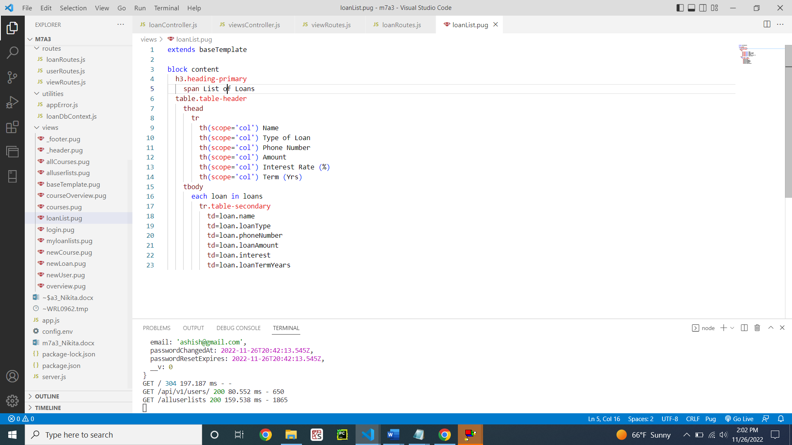

Figure 42: loanList.pug file

Demonstrating the displaying of all loan list (Figure 43)

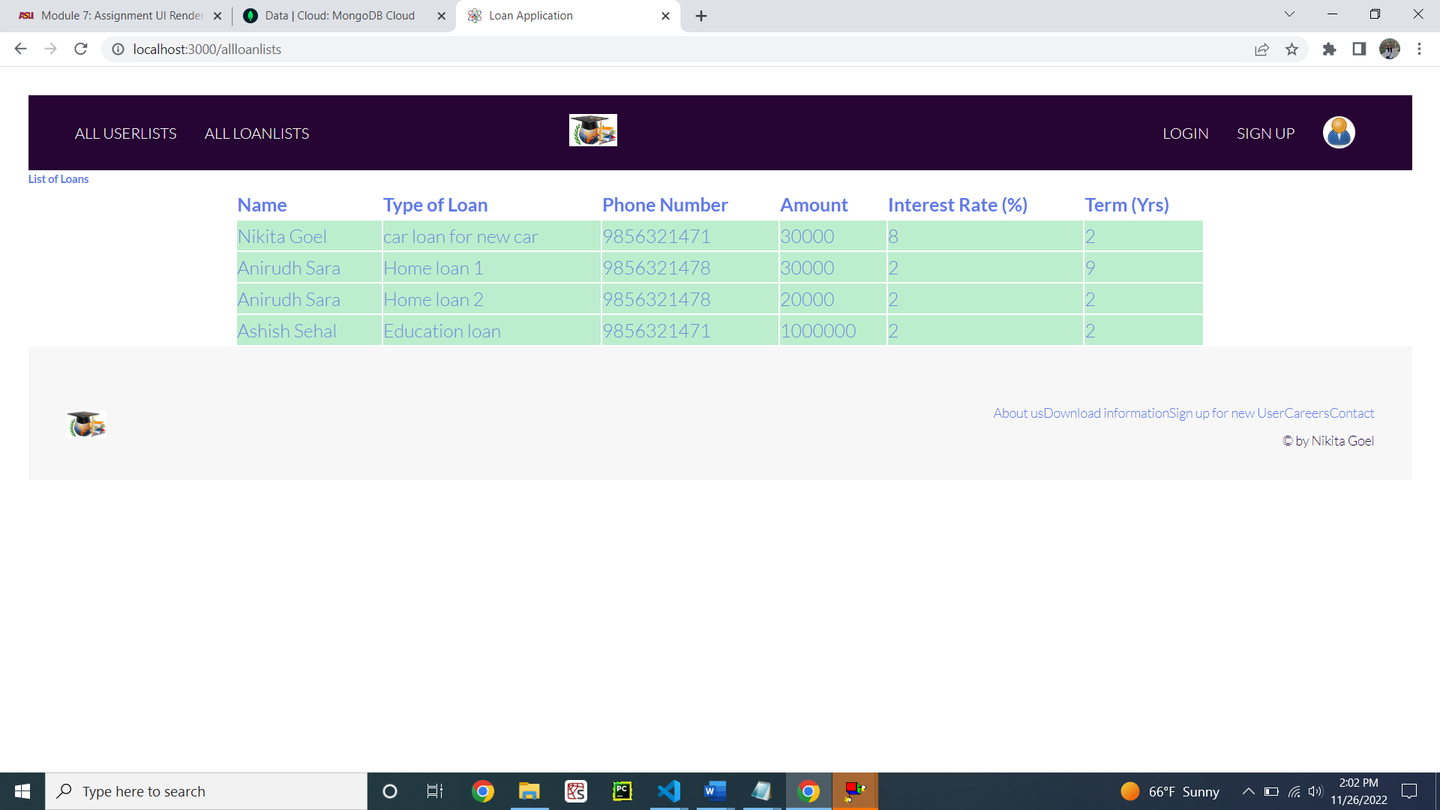

Figure 43: Listing all the loans using the ALLLOANLISTS button

**GitHub Link:** [**https://github.com/nikitagoel7/m7a3**](https://github.com/nikitagoel7/m7a3)